



NATIONAL ECONOMICS UNIVERSITY
COLLEGE OF TECHNOLOGY
Faculty of Mathematical Economics
-------***-------



BACHELOR’S THESIS

TOPIC:
Graph-Based Anomaly Detection in Bitcoin Networks:
A Structural and Temporal Analysis of the Elliptic Dataset

Full name: Tran Thi Huyen Thuong
Specialized: Actuarial Science and Risk Management
Student’s ID: 11226188

Professional Supervisor: Mr. Nguyen Quoc Thanh

HANOI, 2026

Acknowledgement

This thesis marks the completion of a challenging but meaningful academic journey. It represents not only my own effort and persistence, but also the support, guidance, and encouragement I have received from many people along the way.
First and foremost, I would like to express my sincere gratitude to my supervisor, Mr. Nguyen Quoc Thanh, for his valuable guidance, thoughtful advice, and continuous support throughout the process of completing this thesis. His comments and direction helped me clarify my ideas, improve the structure of my research, and remain focused when the work became difficult.
I would also like to thank the Faculty of Mathematics and all lecturers who have provided me with knowledge, discipline, and academic foundation during my years of study. The skills and perspectives I have gained from the programme have been essential to the development of this thesis.
To my friends who have walked this path with me, shared ideas, and always been there for me when I needed someone to confide in, thank you.
I am also sincerely grateful to my friends, colleagues, brothers and sisters at Shinhan Life Vietnam, who have supported me with encouragement, practical advice, and understanding during the time I worked on this thesis. And a special thank you to Ms. Nguyen Ha Phuong, Mr. Nguyen Thanh Dat, Le Trung Kien, and Le Ba Nhat Tien for their unwavering support, practical advice, or simply for reminding me to rest.
Finally, I would like to thank everyone who has contributed to this journey in different ways.
This thesis is mine by name, but by heart, it belongs to you all.

Table of Contents
CHAPTER 1: INTRODUCTION 6
1.1 Background & Motivation 6
1.2 Literature Review 7
1.2.1. From Characteristic-Based Approaches to Network Structure Mining 7
1.2.2. The directed graph nature of the Bitcoin transaction network under the UTXO model 8
1.2.3. Current graph-based approaches and the prioritization for predictive performance 8
1.2.4. Research gap and orientation of the thesis 9
1.3 Research Objectives & Questions 10
1.4 Thesis Structure 10
CHAPTER 2: THEORETICAL FRAMEWORK 11
2.1. Graph Theory Basics 11
2.1.1. Directed graphs 11
2.1.2. Acyclic Graphs 12
2.1.3. Directed Acyclic Graph (DAG) 13
2.1.4. Shortest paths 14
2.2. Asymmetry 15
2.2.1. Degree Centrality 15
2.2.2. Degree Asymmetry Index - DAI 16
2.2.3. Reachability Asymmetry 17
2.3. Centrality 18
2.3.1. Betweenness Centrality 18
2.3.2. Bottleneck ratio 20
2.3.3. Harmonic closeness 21
2.3.4. PageRank 21
2.4. Temporal Graph Analysis 23
2.4.1. Time-step partitioning 23
2.4.2. Skewness and Kurtosis 24
2.4.3. Z-score and Within-timestep Contextualization 26
2.4.4. Risk Propagation Theory and Temporarily Adjacent Context 26
2.5. Statistical Evaluation 29
2.5.1. Mann-Whitney U test and Rank-Biserial Correlation 29
2.5.2. Enrichment ratio 31
2.5.3. Bootstrap Confidence Intervals (CIs) 32
2.5.5. Randomized Approximate Brandes (RA-Brandes) 33
2.6. Theory of Financial Anomaly Mechanisms in Graphs 34
2.6.1. Price-Shock & Hub Dominance 34
2.6.2. Liquidity Freeze 34
2.6.3. Systemic Contagion Mechanism and Risk Propagation 34
2.6.4. Momentum-Reversal 34
CHAPTER 3: DATASET DESCRIPTION 35
3.1. Elliptic Dataset Overview 35
3.2. Label Description 35
3.3. Graph Representation 36
CHAPTER 4: METHODOLOGY 37
4.1. Overall Framework 37
4.2. Label Usage and Evaluation Baseline 38
4.2.1. Label-free metric computation 39
4.2.2. Label groups used in post-hoc evaluation 39
4.2.3. Baseline illicit rate 40
4.2.4. Enrichment analysis 40
4.2.5. Label-coverage diagnostics 40
4.3. Problem Statement 1 41
4.4. Problem Statement 2 44
4.5. Problem Statement 3 47
4.6. Evaluation Framework 53
4.4.1. Descriptive statistics 53
4.4.2. Mann - Whitney U test 53
4.4.3. Enrichment ratio 53
4.4.4. Bootstrap confidence intervals and permutation null 54
CHAPTER 5: EXPLORATORY DATA ANALYSIS 54
5.1. Global Graph Properties 54
5.2. Class Distribution Over Time 56
CHAPTER 6: RESULTS 57
6.1. PS1 - Degree and Reachability Asymmetry 57
6.1.1. Global Structural Statistics 57
6.1.2. Class-Stratified Descriptive Statistics 59
6.1.3. Distributional Comparison and KS Statistics 61
6.1.4. Statistical Significance by Mann-Whitney U Test and Effect Sizes 61
6.1.5. Threshold-Sensitivity Analysis for Degree Asymmetry 63
6.1.6. PU-Adjusted Enrichment with Bootstrap CI and Permutation Null 65
6.1.7. Summary of PS1 Findings 66
6.2 PS2 - Global Centrality 67
6.2.1. Tổng quan phân phối betweenness và harmonic closeness 67
6.2.2. Mann–Whitney U tests for global centrality 68
6.2.3. Label-coverage diagnostic for global betweenness 69
6.2.4. Coverage-gated enrichment analysis for global betweenness 70
6.2.5. Bottleneck ratio analysis 72
6.2.6. Harmonic closeness analysis 73
6.2.7. Backbone subgraph and top-node inspection 75
6.2.8. Summary of PS2 findings 76
6.3 Results – PS3 76
6.3.1. Per-timestep graph partitioning 77
6.3.2. Per-timestep structural metrics 78
6.3.4. Within-timestep z-score standardisation 78
6.3.5. Timestep-level anomaly detection and null calibration 79
6.3.6. Enhanced temporal-context features 81
6.3.7. Enrichment analysis of within-timestep outliers 82
6.3.8. Metric-specific outlier enrichment 83
6.3.9. Label coverage and statistical validation of the headline result 83
6.3.10 Mann–Whitney U tests for PS3 metrics 84
6.3.11. Timestep anomaly score and illicit fraction 85
6.3.12. Summary of PS3 findings 86
CHAPTER 7: CONCLUSION 86
7.1. Summary of Findings 86
7.2. Contributions 88
7.3. Limitations 89
7.4. Future Work 91
7.5. Final Remarks 92
REFERENCES 93

CHAPTER 1: INTRODUCTION

1.1 Background & Motivation
In recent decades, the rapid development of blockchain technology has accelerated the shift from traditional financial systems to digital asset classes, most notably Bitcoin. Unlike centralized banking systems, where transactions are controlled by intermediary institutions, Bitcoin operates on a distributed ledger, allowing transactions to occur directly between parties without the need for intermediary verification. While this feature offers transparency and decentralization, it also poses significant challenges in monitoring and controlling illicit money flows.
One of the core issues is the potential for malicious actors to exploit the relative anonymity of blockchain to carry out activities such as money laundering, illicit financing, or concealing the origin of assets. While every transaction on a blockchain is publicly recorded, tracing and identifying illicit activity is not straightforward, as transactions are often designed as complex chains, potentially involving multiple intermediate steps to obscure the flow of funds.
Historically, the research community has addressed this through Detection paradigms, many previous studies have applied machine learning and deep learning models methods, to classify licit and illicit transactions. However, these methods have several significant limitations. First, most traditional machine learning models process data in tabular form, thus failing to leverage the inherent network structure of blockchain transactions. Second, complex models often lack interpretability, making it difficult to understand the detection mechanism and limiting their applicability in financial monitoring systems where transparency and accountability are required.
In response to these limitations, this thesis is positioned as a Forensic Diagnostic study. Essentially, bitcoin transactions do not exist independently, but are interrelated through the flow of assets. Each transaction can be regarded as a node, and the transfer relationship between transactions forms a directed edge. Therefore, the whole system forms a flow-based network, and its connection structure directly reflects the financial behavior of participants.
Structural analysis of the graph allows for the exploration of the geometric characteristics and location of each transaction within the network, such as the level of money flow reception and distribution, or the intermediary role in connecting different parts of the system. Furthermore, the temporal dimension is also crucial, as illicit activities often do not occur statically but manifest as sudden fluctuations over time, for example, the appearance of unusual transaction clusters within a short period. Therefore, combining structural and temporal analysis provides a more comprehensive ability to identify anomalous signals.
This thesis uses the Elliptic dataset – one of the largest and most widely used labeled Bitcoin transaction datasets in academic research today. This dataset provides a graphical representation of Bitcoin transactions over time, allowing for the analysis of network evolution. Notably, the graphs in Elliptic are Directed Acyclic Graphs (DAGs), meaning there are no cycles. This characteristic reflects the nature of the Bitcoin system, where a transaction can only use the output from previous transactions and cannot create loops. Therefore, the direction of the edges in the graph clearly indicates the flow of value, from source to destination transactions.
Based on these characteristics, this thesis chooses the method based on Graph Analysis, without using complex Machine Learning model, aiming at exploring and explaining the structure and time characteristics that can distinguish licit and illicit transactions. This method not only helps to clarify the formation mechanism of abnormal behavior in Bitcoin Network, but also aims to establish interpretable detection rules that meet the actual requirements in the field of financial supervision.

1.2 Literature Review

1.2.1. From Characteristic-Based Approaches to Network Structure Mining
In the early stages, research into detecting illicit transactions on the blockchain relied primarily on static features extracted from individual transactions, such as transaction value, fees, or statistics related to wallet addresses. However, this approach had a fundamental limitation: it treated each transaction as an independent observation, whereas in reality, Bitcoin transactions are tightly linked through the flow of value within the network.
The introduction of the Elliptic dataset and the work of Weber et al. (2019) marked a significant shift, as transaction data was modeled as a Temporally Directed Graph. This allowed for the exploitation of relational information between transactions, opening up a network-based analysis approach in the anti-money laundering problem.
Recent review studies, notably the system survey by Deprez et al. (2025), indicate that integrating graph information significantly improves forecasting performance compared to non-relational methods. In particular, the period 2023–2026 saw a clear shift from static graphs to dynamic graphs to capture the evolution of the network over time. For example, the Balanced-BiEGCN (2025) model used a two-dimensional time-feature fusion mechanism to capture long-range dependencies in dynamic graphs. Additionally, the ChronoWave-GNN (2026) study introduced a dual-domain (time-frequency) analysis approach, showing that anomalous behaviors such as money mixing services (mixers) often leave behind characteristic high-frequency "pulse" signatures that traditional models miss. In addition, a new research direction has begun to view money laundering behavior not only as individual nodes but as temporal patterns. Several recent studies show that illicit activities can manifest as burst behaviors with frequency characteristics different from licit transactions. This approach suggests that anomalous signals are not only in the static structure but also in the dynamics of money flow.

1.2.2. The directed graph nature of the Bitcoin transaction network under the UTXO model
Representing the Bitcoin transaction network as a directed graph is not merely a modeling choice, but stems directly from the operational logic of the Unspent Transaction Output (UTXO) model. In this model, each transaction is formed by consuming the unspent outputs from previous transactions, thereby creating a directed dependency structure between transactions. This structure is often modeled as a Directed Acyclic Graph (DAG), where the edges reflect the consumption-creation relationship between transactions. Based on this, many studies have shown that transaction graphs not only have technical significance but also directly reflect the economic behavior within the network. Based on this characteristic, studies by Caprolu et al. (2021) and empirical reports in 2025 confirm that transaction chains (T-DAGs) allow tracing the propagation of value without relying entirely on wallet addresses, which are easily changed.
Specifically, two basic behaviors commonly observed include:
- Accumulation: many inputs, few outputs;
- Distribution: few inputs, many outputs.
Typical money laundering strategies such as mixing services or peeling chains often combine these two behaviors by pooling multiple sources of funds before separating them through several intermediate steps.
In this context, the degree asymmetry index can be seen as a direct mathematical representation of these behaviors. Using purely structural indices reduces reliance on surface features (e.g., wallet addresses). This is particularly important in adversarial environments like AML, where actors have strong incentives to evade detection. Furthermore, some recent studies have indicated that illicit nodes tend to avoid central locations in the network and appear more frequently in peripheral regions to limit their traceability.

1.2.3. Current graph-based approaches and the prioritization for predictive performance
Most modern research on elliptic datasets focuses on node classification using deep learning models on graphs, particularly graph neural networks (GNNs) such as GCN, GAT, and EvolveGCN. These methods leverage structural information and transaction characteristics over time to achieve high predictive performance in distinguishing between licit and illicit transactions.
Recent extensions, notably Elliptic++, further integrate actor-level features and relationships between wallet addresses to enhance the ability to identify complex behavior within the blockchain ecosystem.
However, this prioritization of predictive performance has created an "interpretation crisis". Complex GNN models are often treated as "black boxes" (Zakaria et al. (2025)), making them difficult to interpret in financial crime investigation reports, for example Suspicious Activity Reports (SARs), that demand high transparency. Recent studies highlight that a lack of interpretability can diminish the practical value of models, even those with high predictive performance.
To address this, research trends since 2024 have shifted towards subgraph structural analysis. The work "The Shape of Money Laundering" (2024) has defined specific geometric forms such as "peeling chains" and "nested services", providing a more intuitive and easily interpretable view of illicit money flows.
In addition, model-based methods such as Variational Graph Autoencoders (VGAE) show that while they perform well, they may miss important structural regions - especially the periphery of the network. This opens up an additional role for classical structural indicators such as betweenness centrality, which can detect nodes acting as intermediaries in the flow of money.

1.2.4. Research gap and orientation of the thesis
Based on a synthesis of existing research, this thesis identifies three key research gaps:
- Lack of purely structural interpretive insights: Much of current research focuses on optimizing accuracy through supervised learning, resulting in the role of isolated structural signals (such as order asymmetry or intermediate position) not being systematically and explicitly analyzed as independent indicators.
- The challenge of camouflage behavior: Studies from 2025 indicate that criminals tend to interact with licit entities to disrupt structural signals (heterophily problem). Current Deep Learning models often struggle to distinguish between "less homophilic" but licit nodes and illicit nodes engaging in camouflage behavior.
- Limitations in exploiting negative signals: While current methods attempt to find "positive signs" of crime, using network structures to build "negative filters".
Based on the aforementioned gaps, this thesis focuses on analyzing the structural and temporal characteristics of the Bitcoin network in a clear and explicit manner. The main objective is to assess the ability to distinguish between licit and illicit transactions based on purely geometric (Graph-based) indicators, without directly relying on complex machine learning models, thereby developing highly interpretive interpretable structural diagnostics that are suitable for the practical requirements of the financial supervision industry.

1.3 Research Objectives & Questions
Starting from identified research gaps, this thesis aims to use graph algorithms and indicators to identify structural features that can distinguish between illicit and licit transactions in the Bitcoin network. Instead of focusing on optimizing predictive models, the research concentrates on analyzing the role of structural signals explicitly, through graph measures with clear interpretive meaning.
The specific objective of this thesis is to quantitatively assess whether structural and temporal dynamics, including degree asymmetry, betweenness centrality, and temporal structural anomalies, actually provide structural evidence over illicit transactions.
Based on this, the thesis focuses on answering three main Research Questions (RQ):
- RQ1: To what extent does local inflow–outflow imbalance, measured by degree and reachability asymmetry, characterise the structural behaviour of labelled illicit transactions?
- RQ2: To what extent do betweenness-related global centrality metrics explain the structural positioning of labelled illicit transactions under severe label scarcity?
- RQ3: Do temporal structural variations across timesteps and within-timestep structural outlierness reveal meaningful patterns associated with labelled illicit transactions?
In order to answer these questions, the study is divided into three Problem Statements (PS), corresponding to three main signal groups:
- PS1 - Structural Imbalance: Evaluates whether labelled illicit transactions differ from labelled licit transactions in local inflow–outflow and multi-hop reachability asymmetry.
- PS2 - Intermediary position: Examines the structural positioning of labelled illicit transactions through global centrality metrics, while explicitly evaluating label-coverage limitations in high-centrality regions.
- PS3 - Temporal anomalies: Evaluates both cross-timestep structural variation and node-level structural outlierness within each timestep.

1.4 Thesis Structure
The remainder of this thesis is organized into the following main sections:
Chapters II & III – Theoretical and Data Foundations: Chapter II introduces the fundamental concepts of graph theory, including directed graphs, centrality measures, and temporal graph analysis. Chapter III presents the Elliptic dataset, including its graph structure, labeling scheme, and key data challenges.
Chapters IV & V – Methodology and Exploratory Analysis: Chapter IV outlines the proposed structure-first analytical framework, including the three problem statements (PS1–PS3) focusing on degree asymmetry, betweenness centrality, and temporal anomalies. Chapter V provides exploratory analysis to characterize the global structure, degree distributions, and temporal patterns of the transaction network.
Chapters VI & VII – Results and Conclusion: Chapter VI presents the empirical findings for each problem statement, evaluating the extent to which structural and temporal signals distinguish illicit transactions. Chapter VII summarizes the main findings, highlights the contributions of the structure-first approach, and suggests directions for future research.

CHAPTER 2: THEORETICAL FRAMEWORK

2.1. Graph Theory Basics

2.1.1. Directed graphs
Unlike undirected graphs where relationships are bidirectional, directed graphs require edges to have clearly defined starting and ending points. Needham & Hodler defined relationships directed toward a node as in-links and relationships originating from that node as out-links.
Direction adds another dimension of information. Relationships of the same type but in opposing directions carry different semantic meaning, expressing a dependency or indicating a flow.
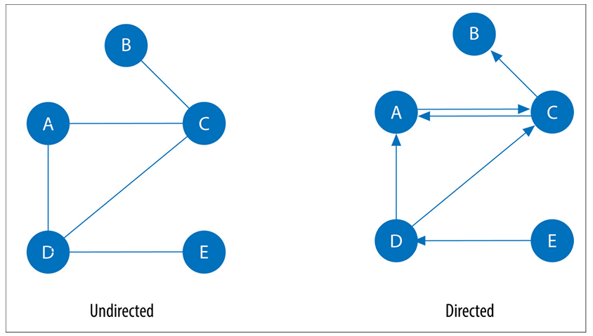
Figure 2.1.
In the Bitcoin network, this directionality reflects the movement of money: In-degree represents the amount of input funds consumed by a transaction, while Out-degree represents the amount of output generated to transfer value. This asymmetry between input and output links is the basis for identifying anomalous behaviors such as the accumulation or dispersion patterns commonly observed in money laundering schemes.

2.1.2. Acyclic Graphs
In graph theory, cycles are paths through relationships and nodes that start and end at the same node. An acyclic graph has no such cycles.
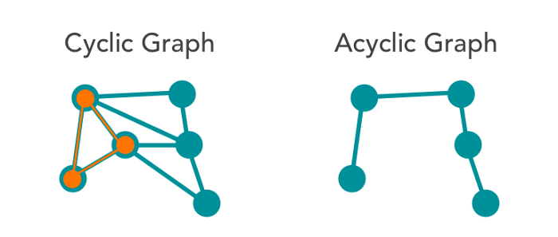
Figure 2.2. Undirected
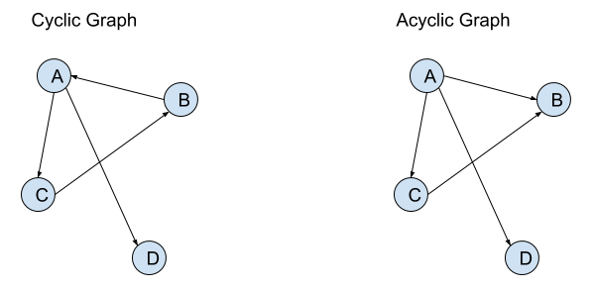
Figure 2.3. Directed

2.1.3. Directed Acyclic Graph (DAG)
By definition, a graph is a DAG if the paths along the edges never repeat a node already visited, meaning it is impossible to start and end at the same point. The consequence of this structure is the existence of "leaf nodes", or endpoints that cannot be traversed further.
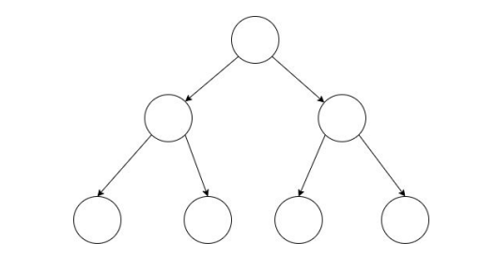
Figure 2.4. Binary tree is an example of DAG
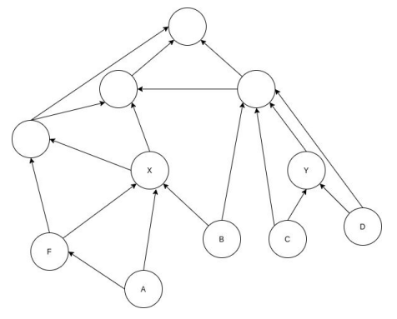
Figure 2.5. A more complex DAG structure
The DAG nature of Bitcoin stems directly from the UTXO (Unspent Transaction Output) model: a transaction can only consume the unspent outputs from past transactions and cannot use its own results or future transactions to form a loop.

2.1.4. Shortest paths
Paths are fundamental to graph analytics and algorithms. A path is defined as a group of nodes and the relationships connecting them. A shortest path is a route between two nodes that has the fewest hops or the lowest total edge weight.
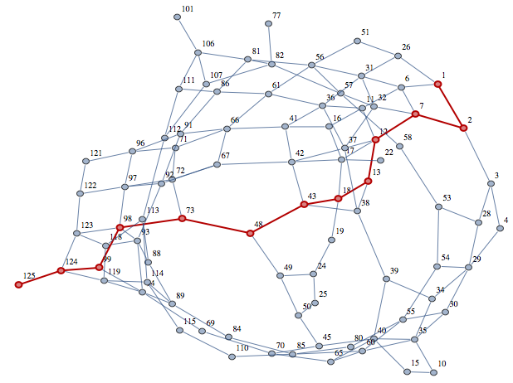
Figure 2.6.
The determination of the shortest path is the mathematical basis of many advanced analysis methods. In the context of AML, the shortest path algorithm is not only helpful to track the flow of money from the source to the destination, but also the core component of calculating the central index, which is helpful to determine the "chokepoints" that financial criminals usually use to connect different trading clusters to hide their traces.

2.2. Asymmetry

2.2.1. Degree Centrality
Degree Centrality was proposed by Linton C. Freeman in his 1979 paper “Centrality in Social Networks: Conceptual Clarification”. In traditional network theory, Degree Centrality is often used to measure the importance or popularity of a node based on the number of direct connections. It counts the number of incoming and outgoing relationships from a node, and is used to find popular nodes in a graph.
Based on the UTXO model, each node (transaction) has a defined cash flow direction, so the degree of node $v$ is separated into two independent components: In-degree $k_{in}(v)$and Out-degree $k_{out}(v)$.
Input $k_{in}(v)$: Represents the number of inputs that the $v$ transaction consumes. According to Needham & Hodler (2019), a high $k_{in}(v)$reflects “Consolidation” behavior. In the forensic context, this is a sign of pooling assets from multiple small sources in preparation for the next money laundering steps.
Output $k_{out}(v)$: Represents the number of newly created outputs by node $v$. The high $k_{out}(v)$reflects the "spreading" behavior. This is the core feature of camouflage technology, such as Peeling Chains, in which funds are divided into a series of addresses to obscure their sources.

2.2.2. Degree Asymmetry Index - DAI
In blockchain, the relationship between these two indicators reveals behavioral archetypes. While licit entities typically maintain a relative balance between inflows and outflows, il licit actors often exhibit degree asymmetry.
To quantify the structural mismatch between asset inflows and outflows, this study establishes the Degree Asymmetry Index (DAI). While graph asymmetry indices have been widely discussed in structural mathematics (e.g., Koam et al.'s Weighted Asymmetry Index, 2024), in transaction analysis, the DAI is normalized to directly reflect the flow imbalance:
$$DAI(v)=\frac{k_{in}(v) - k_{out}(v)}{k_{in}(v) + k_{out}(v)}$$
In this context, $DAI(v)$ in [-1, 1]. This index provides a highly interpretive measure of the economic behavior of transactions:
- Accumulation Behavior $DAI(v) → 1$: Occurs when $k_{in}(v) ≫ k_{out}(v) .$These nodes act as "convergence points" of money flow, often associated with criminal wallets after attacks or il licit money collection services.
- Distribution Behavior $DAI(v) → -1$: Occurs when $k_{in}(v) ≪ k_{out}(v)$. This is a typical form of faucet services or nodes that initiate the layering process in the traditional three-step money laundering model.
- Balanced Flow $DAI(v) ≈ 0$: Reflects the 1-in/1-out or 2-in/2-out structure common in licit commercial transactions or simple transition steps of ordinary users.
The study by Bellei & Xu (2024) in "The Shape of Money Laundering" confirms that anomalous subgraph patterns (such as nested services) always exhibit extreme deviations in the hierarchical distribution.
Statistical Separation: Non-parametric tests (Mann-Whitney U) on the Elliptic dataset show that illicit nodes have a positive average DAI (+0.056), while licit nodes tend to have a negative average DAI (-0.069). This suggests that the Illicit pool in Bitcoin tends to accumulate higher cash flow than the network average.

2.2.3. Reachability Asymmetry
We say the v is reachable from u in graph G if and only if there is a path from u to v.
R⁺ ($υ$) = { $u∈$V : $υ⇝$ u }
R⁻ ($υ$) = { $u∈$V : $u⇝$ $υ$ }
Where $υ⇝ u$ denotes the existence of a directed path from $υ to u$
Degree asymmetry measures only 1-hop (immediate inputs/outputs). Reachability Asymmetry extends to the entire DAG, measuring whether a node has more upstream sources or downstream sinks across the entire transaction chain.
For a node v in a directed acyclic graph G:
$anc(υ)= \{ u : u⇝ * v\}$
$desc(υ)= \{ w : v⇝ * w\}$
- where anc(v) denotes the number of upstream nodes u that can reach v through a directed path.
- where desc(v) denotes the number of downstream nodes w that are reachable from v through a directed path.
$RA(υ)=log\frac{1+ anc(υ)}{1+ desc(υ)}$
The logarithmic transformation is used to compress the heavy-tailed distribution of ancestor and descendant counts, while the +1+1+1 term prevents undefined values when either count is zero.
The interpretation of RA(v) is as follows:
RA value | Interpretation
RA(v) > 0 | The node has more upstream than downstream reachability, suggesting an accumulator position where funds converge from multiple sources.
RA(v) < 0 | The node has more downstream than upstream reachability, suggesting a distributor position where funds are dispersed toward multiple destinations.
RA(v) ≈ 0 | The node has a relatively balanced upstream and downstream reachability profile, suggesting a balanced throughput position.
Reachability Asymmetry differs from the Degree Asymmetry Index (DAI). While DAI captures only the immediate one-hop imbalance between in-degree and out-degree, RA captures the entire reachability cone of a node in the DAG. Therefore, a node may have DAI(v) ≈ 0 but RA(v) ≫ 0 if it is positioned at the end of a long upstream transaction chain.

2.3. Centrality
Centrality is all about understanding which nodes are more important in a network. But what do we mean by importance?
We’ll cover the following algorithms:
• Betweenness Centrality for finding control points, including an alternative for approximation
• PageRank for understanding the overall influence, including a popular option for personalization

2.3.1. Betweenness Centrality
Sometimes, the most important cog in a system isn't the person with the most obvious power or the highest position. Sometimes it's the intermediaries connecting the groups or the brokers who have the most control over resources or the flow of information. When Linton C. Freeman presented Betweenness Centrality in his 1971 paper, "A Set of Measures of Centrality Based on Betweenness," it was regarded as one of the "three distinct intuitive concepts of centrality".
Betweenness Centrality is a method to detect the influence of nodes on information flow or resources in a graph. It is usually used to find nodes that are bridges from one part of a graph to another. In a linked graph, the Betweenness Centrality algorithm first determines the shortest (weighted) path between each pair of nodes. The number of these shortest pathways that pass through each node determines its score. A node's score increases with the number of shortest pathways it is on. If a node is on every shortest path connecting two other nodes, it is deemed crucial.
The following formula's findings for all shortest pathways are added to determine a node's betweenness centrality:
$$B(u)=\sum_{s ≠ u ≠ t}^{ }{\frac{p(u)}{p}}$$
Where
- $u$ is a node
- $p$ is the total number of shortest paths between nodes$s$ and $t$
- $p(u)$ is the number of shortest paths between nodes$s$ and $t$ that pass through node $u$
According to Needham & Hodler (2019), nodes with high $B(u)$ act as "gatekeepers" or chokepoints of the network. In the Bitcoin financial system, these nodes are often exchanges, large payment services, or "hub" wallets that function to coordinate the flow of funds (flow routing) for thousands of users.
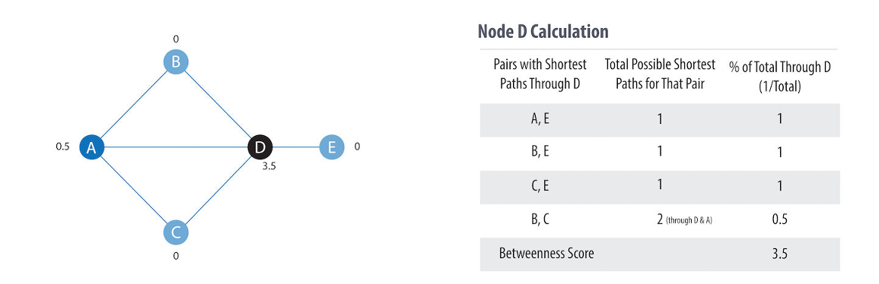
Figure 2.7. Basic concepts for calculating betweenness centrality
A key theoretical contribution in the 2024-2026 period is the redefining of the role of Centrality in crime detection. In contrast to social networks, Koronaios's (2025) research indicates that illicit actors tend to possess significantly lower Betweenness scores compared to licit actors. This leads to the concept of "anti-central nodes": sophisticated criminals actively avoid central chokepoints to hide in sparse subgraphs located on the periphery of the network to evade the scrutiny of AML algorithms.
Therefore, the "Negative Structural Signal" theory is proposed: instead of directly pointing out illicit transactions, high centrality helps eliminate "noise" from licit organizations, allowing models to focus on the periphery of the graph, where illicit activities actually take place, to avoid scrutiny from central entities.

2.3.2. Bottleneck ratio
A limitation of raw betweenness centrality is that the highest betweenness scores are often assigned to large exchange-like hubs. These nodes are typically licit service entities with very high degree. As a result, they can dominate the top betweenness percentiles and cause label coverage to collapse in high-betweenness regions.
The motivation for the bottleneck ratio is to distinguish between a node that is globally central simply because it is a large hub and a node that functions as a genuine structural bottleneck. A laundering intermediary is expected to have high betweenness relative to its degree: it lies between otherwise sparse regions of the graph and channels flow through a narrower structural position. By contrast, an exchange may also have high betweenness, but its degree and the degree of its neighbours are also high; therefore, its bottleneck ratio is lower.
$$BR(υ) =\frac{B(υ)}{d\left(υ\right) . {\overline{d}}_{N} \left(υ\right)+ ε }$$
where:
- $B(υ)$ denotes the normalized betweenness centrality of node v;
- $d\left(υ\right)$ denotes the total degree of node v;
- ${\overline{d}}_{N} \left(υ\right)$ denotes the mean total degree of all neighbouring nodes of v;
- $ε= {10}^{-12}$ is a small constant added to avoid division by zero.
The bottleneck ratio is therefore interpreted as follows:
Node type | Structural pattern | Expected BR interpretation
Exchange-like hub | High BC(v), very high d(v), and high - degree neighbours | Lower BR(v), because high betweenness is explained by hub size
Laundering intermediary | High BC(v), moderate d(v), positioned between sparse regions | Higher BR(v)BR(v)BR(v), because the node acts as a true bottleneck
Isolated or peripheral node | BC(v) ≈ 0 | BR(v) ≈ 0, because the node does not mediate shortest paths
In this sense, the bottleneck ratio acts as a degree-normalised proxy for bridging efficiency. It does not simply ask whether a transaction has high betweenness, but whether it has high betweenness relative to its local connectivity environment.

2.3.3. Harmonic closeness
Classical closeness centrality measures how close a node is to all other nodes in a network, usually through the inverse of the average shortest path distance. However, in directed and disconnected graphs, classical closeness centrality has limitations because some nodes may be inaccessible, resulting in infinite or indeterminate distances.
Harmonic closeness overcomes this limitation by summing the inverse of the shortest path distances and assigning a contribution value of 0 to inaccessible nodes:
$$C_{H}(v)=\sum_{u≠v}{\frac{1}{d(v,u)}}$$
where d(v,u) is the shortest path distance from v to u, and 1/d(v,u) = 0 when u is inaccessible from v.
In Bitcoin transaction graphs, harmonic closeness reflects the efficiency with which a transaction can access other transactions via directed paths. Compared to betweenness centrality, harmonic closeness reflects another dimension of network positioning. Betweenness identifies nodes located between other nodes, while harmonic closeness identifies nodes located near multiple accessible nodes. Therefore, harmonic closeness is useful in detecting transactions that don't necessarily act as bridges, but still occupy positions with structural influence within the directed transaction flow.

2.3.4. PageRank
The introduction of the PageRank algorithm in the late 1990s marked not only a technological leap but also a revolution in thinking about organizing human knowledge in the digital space. Before Google, early search engines like AltaVista and Yahoo relied primarily on plain text analysis, where the position and frequency of keywords determined a website's ranking. However, this method quickly revealed serious flaws as web administrators began abusing keyword stuffing techniques to manipulate results. In this context, Larry Page and Sergey Brin, two graduate students at Stanford University, proposed a completely new approach: using the interconnected structure of the global network to measure the value and credibility of information.
PageRank is the best known of the centrality algorithms. It measures the transitive (or directional) influence of nodes. All the other centrality algorithms we discuss measure the direct influence of a node, whereas PageRank considers the influence of a node’s neighbors, and their neighbors.
PageRank measures the number and quality of incoming relationships to a node to determine an estimation of how important that node is. Let's assume there is any website u, its PageRank score is determined by the following formula:
$$PR(u)= (1 - d) + d\left(\frac{PR\left(T_{1}\right)}{C\left(T_{1}\right)} + ... + \frac{PR\left(T_{n}\right)}{C\left(T_{n}\right)}\right)$$
- $PR(u)$: This is the PageRank index of the webpage being calculated, which represents the final reputation value of the webpage.
- $T_{i}$: Websites containing links pointing to page u. In this model, they are considered the sources of prestige (votes).
- $PR(T_{i})$: The current PageRank score of the source pages $T_{i}$. A source page with a high score will transmit more authority than a page with a low score.
- $C\left(T_{1}\right)$: The number of out-degree links from the source page $T_{i}$. When a website shares links, its power is divided equally among all the pages it points to.
- $d$: Damping factor, an important adjustment parameter ranging from 0 to 1, usually defaulted to 0.85. It can be thought as the probability that a user will continue clicking. This helps minimize rank sink.
- $(1 - d)$: The probability that a user will directly access a page without going through any link, ensuring each page has a minimum score to remain in the system.
The core mechanism of PageRank is based on probability distribution. When page $T_{1}$ links to page $u$, it doesn't transfer its full power but only a portion, $\frac{PR\left(T_{1}\right)}{C\left(T_{1}\right)}$. This reflects an objective reality: if a reputable website points to too many different addresses, the value of each link will be diluted. Conversely, a link from an extremely high-quality source with few outbound links will give a huge boost to the target page's ranking.
The damping factor $d$ simulates the probability that a user will continue clicking on links on the current page. With a common value of 0.85, this means there is an 85% chance the user will follow an existing link and a 15% chance they will get bored and leave the current page to open a random new page by entering a URL into the address bar.
Including this parameter in the formula is not only intended to reflect human behavior but is also a crucial mathematical solution to address network structure problems. Without $d$ (i.e., $d$ = 1), a set of websites linking in a circular fashion but not pointing outwards would become a "rank sink," constantly absorbing and accumulating points without sharing them with the rest of the internet. The $d$ factor ensures that the PageRank flow is always redistributed, preventing points from getting stuck in closed cluster structures.
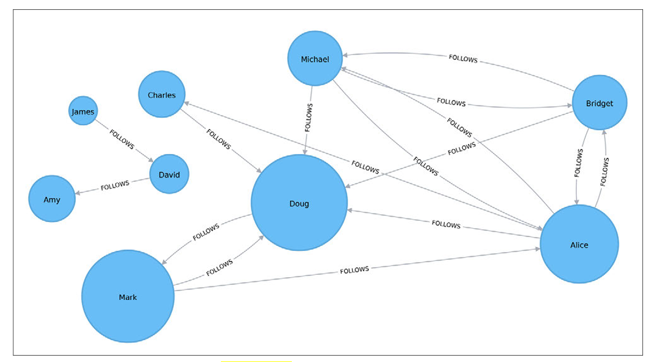
Figure 2.8. Visualization of PageRank
Doug has the highest PageRank because he is followed by all other users in his subgraph. Although Mark only has one follower, that follower is Doug, so Mark is also considered important in this graph. It's not just the number of followers that matters, but also the importance of those followers.

2.4. Temporal Graph Analysis
Bitcoin is a place where the network structure is constantly evolving. Static analysis often misses the behavioral impulses of criminals.

2.4.1. Time-step partitioning
Due to the immutability of each transaction in the UTXO model (each transaction appears only once), this study employs the Time-step partitioning method. The global graph is divided into discrete time-step window snapshots ($G_{1}$, $G_{2}$,…, $G_{t}$), each window representing a non-cyclic directed subgraph $G_{t}= (V_{t}, { E}_{t})$.
Organized crime activities such as fraud rings or money-mixing services often trigger simultaneous attacks, causing "shocks" to the overall structure of the network.
Theoretical concept | Description in the context of Bitcoin | Applications in PS3
Snapshot $G_{t}$ | A collection of transactions and relationships over a period of time | Basic analysis unit
Edge Activation | The occurrence of a transaction at time t | The start of the flow
Temporal Sparsity | Sparsity of nodes passing through snapshots | The main challenge in node tracking
Structural Drift | Changes in network characteristics over time | System-level abnormal signal

Structural Drift theory assumes that under normal market conditions, the macro-metrics of a network (such as average edge density, order distribution, or average centrality) will fluctuate within a stable range. A sudden shift beyond these statistical norms is considered a sign of systemic anomalies, potentially related to cyberattacks, exchange failures, or large-scale money laundering operations.

2.4.2. Skewness and Kurtosis
When analyzing the structural drift of a network over many time steps, using only the mean and standard deviation is insufficient to describe networks with heavy-tailed distributions like Bitcoin.
Skewness measures the asymmetry of a probability distribution around its mean, indicating if data is concentrated on one side. It identifies the direction and magnitude of distortion from a normal, bell-shaped curve. Values can be positive (right-skewed), negative (left-skewed), or zero (symmetrical).
$$γ_{1} = \tilde{μ_{3}} = E\left[{\left(\frac{Χ - μ}{σ}\right)}^{3}\right] = \frac{μ_{3}}{σ^{3}} = \frac{E\left[{\left(Χ - μ\right)}^{3}\right]}{{\left(E\left[{\left(Χ - μ\right)}^{2}\right]\right)}^{3/2}}$$

- Zero Skew (Symmetrical): Normal distribution where the mean, median, and mode are equal.
- Positive Skew (Right-skewed): The tail on the right side is longer or fatter; the mean is typically greater than the median. Common in income or house price data.
- Negative Skew (Left-skewed): The tail on the left side is longer or fatter; the mean is typically less than the median.
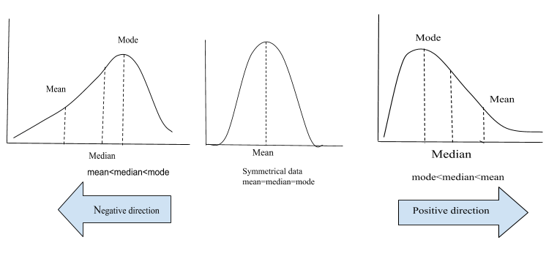
Figure 2.9.

A sudden increase in Skewness in the entry level of a snapshot indicates that capital accumulation is concentrated in a very small number of entities, which often occurs in Ponzi schemes or large-scale hacks.

Kurtosis is a statistical measure that describes the "tailedness" of a probability distribution, indicating the frequency of extreme outliers relative to a normal distribution. It focuses on the tails of the distribution rather than its peak, with higher values signaling more extreme, "fat" tails and lower values indicating lighter, "thin" tails. It measures the combined weight of the tails relative to the rest of the distribution.

$${Kurt}_{X} = E\left[{\left(\frac{Χ - μ}{σ}\right)}^{4}\right] = \frac{μ_{4}}{σ^{4}} = \frac{E\left[{\left(Χ - μ\right)}^{4}\right]}{{\left(E\left[{\left(Χ - μ\right)}^{2}\right]\right)}^{2}}$$

- Leptokurtic (High): Positive excess kurtosis, indicating fat tails and a higher risk of extreme outliers.
- Mesokurtic (Medium): Excess kurtosis near 0, similar to a normal distribution.
- Platykurtic (Low): Negative excess kurtosis, indicating thin tails and fewer, less extreme outliers.
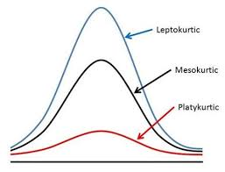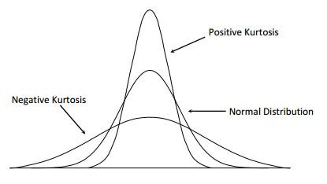
Figure 2.10.

High kurosis indicates the presence of extreme outliers that far exceed the average. In financial theory, extremely high kurosis is often associated with "Price Shocks" or periods of strong liquidity fluctuations, where the network structure is dominated by a few hyperlinked nodes.

2.4.3. Z-score and Within-timestep Contextualization
A transaction might be highly central to the entire Bitcoin history, but normal within the context of a strong market surge. Therefore, the "Within-timestep contextualization" theory suggests that anomalies should be evaluated against peer nodes within the same timeframe.
The Z-score is used to quantify the degree to which an observation $x$ deviates from the group mean$μ$ in terms of standard deviations $σ$:
$$Ζ= \frac{x - μ}{σ}$$
This theory allows for the standardization of different scales of 49 snapshots in the Elliptic dataset, which helps to identify "local outliers" - transactions with the most unusual structural positions at the very moment they occur.

2.4.4. Risk Propagation Theory and Temporarily Adjacent Context

In the PS3, the theory of Temporal Neighborhood Context extends the analysis from a single node to its Predecessors and Successors. The underlying hypothesis is "Risk Propagation": a seemingly normal transaction may be deemed abnormal if it receives BTC from an abnormally structured transaction in the previous timestep.

Calculating features such as the "Average of the Centrality of the Predecessor/Successor Nodes" helps model the history of money flow, creating a comprehensive picture of how risk is accumulated and transmitted within Bitcoin's DAG structure.

Two types of temporal neighbourhood context features are constructed: predecessor context and successor context.

A. Predecessor context: upstream risk

Predecessor context captures the structural profile of transactions that directly or indirectly feed into a focal transaction. For a node v, let $P_{k}(υ)$ denote the set of predecessor nodes of v within k hops. The predecessor - based features are defined as:

$$μ_{pred}^{(BC)}(υ) = \frac{1}{\left|P_{k}(υ)\right|} \sum_{u ϵ P_{k}(υ)}{B_{t}(u)}$$

$$μ_{pred}^{(asym)}(υ) = \frac{1}{\left|P_{k}(υ)\right|} \sum_{u ϵ P_{k}(υ)}{{DAI}_{t}(u)}$$
$${σ_{pred}^{(deg)}(υ) = Std \{dt (w) : w ϵ S}_{k}(υ)\}$$

B. Successor context: downstream propagation

Successor context captures the structural profile of transactions that receive outputs from a focal transaction. For a node v, let $S_{k}(υ)$ denote the set of successor nodes of v. The successor-based features are defined as:

$$μ_{suc}^{(BC)}(υ) = \frac{1}{\left|S_{k}(υ)\right|} \sum_{u ϵ S_{k}(υ)}{B_{t}(u)}$$

$$μ_{suc}^{(asym)}(υ) = \frac{1}{\left|S_{k}(υ)\right|} \sum_{u ϵ S_{k}(υ)}{{DAI}_{t}(u)}$$

$${σ_{suc}^{(deg)}(υ) = Std \{dt (w) : w ϵ S}_{k}(υ)\}$$
These features describe how funds propagate after leaving a transaction. A high standard deviation of successor degree indicates uneven downstream dispersion, meaning that outputs are distributed toward structurally heterogeneous destinations rather than evenly across similar nodes.

In addition to direct predecessor and successor features, this thesis constructs cascade-based temporal context features to capture how quickly and how concentrated transaction flow propagates through the DAG. These features are used as supporting temporal descriptors in PS3.

Cross-timestep ancestor span

where $P_{k }(υ)$ denotes the set of predecessor or ancestor nodes of v within k hops, and $t(u)$ denotes the timestep of node u.

This feature measures how widely the upstream history of a transaction is spread across time. A larger value means that the ancestors of node v come from a wider range of timesteps. A smaller value means that the upstream transactions are concentrated within a short time window.

In simple terms, $ts_spananc(υ)$answers the question: “How long is the temporal history of the upstream transactions feeding into node v?”

$${ts_span}_{anc}(υ) = \max_{u ϵ P_{k }(υ)}{t (u)}-\min_{u ϵ P_{k}(υ)}{t(u)}$$

Flow velocity

$$vel(υ) = \frac{cascade_depth(υ)}{max⁡({ts_span}_{anc}\left(υ\right),1)}$$
where $cascade_depth(υ)$ is the longest directed path length ending at node v, and ${ts_span}_{anc}\left(υ\right)$ is the ancestor timestep span.

This feature measures how many graph layers are traversed per timestep. A high value means that a transaction is reached through many directed hops within a short time span. In the context of transaction-flow analysis, this may indicate rapid movement of value through multiple transaction layers.

In simple terms, vel(v) answers the question: “How quickly does transaction flow move through multiple graph layers before reaching node v?”

A higher flow velocity may be consistent with coordinated layering behaviour, but in this thesis it is treated only as a structural descriptor rather than a direct indicator of illicit activity.

Herfindahl Concentration Index

Because the public Elliptic edge list does not provide transaction-value weights for each edge, this thesis uses degree-based structural proportions as a proxy for concentration. The incoming Herfindahl Concentration Index is defined as:

$${HHI}_{in}(υ) = \sum_{u ϵ pred(υ)}{{(\frac{d(u)}{\sum_{u^{,}}{d(u^{,})}})}^{2}}$$

where pred(v) is the set of predecessor nodes of v, and d(u) is the total degree of predecessor node u.

This feature measures whether the incoming structural context of node v is concentrated in a few predecessors or evenly distributed across many predecessors. If one predecessor dominates the incoming structure, ${HHI}_{in}(υ)$ will be close to 1. If the incoming structure is evenly distributed across many predecessors, the value will be closer to 1/n, where nnn is the number of predecessors.

In simple terms, ${HHI}_{in}(υ)$ answers the question:
Is the upstream context of node v dominated by one main predecessor, or is it spread across multiple predecessors?

The interpretation is as follows:

HHI value | Interpretation
$${HHI}_{in}(υ) ≈ 1$$ | Highly concentrated upstream structure; one predecessor dominates
$${HHI}_{in}(υ) ≈ 1/n$$ | More evenly distributed upstream structure across (n) predecessors
Higher HHI | More concentrated or funnel-like structure
Lower HHI | More dispersed upstream structure

Since this HHI is based on degree proportions rather than monetary transaction values, it should be interpreted as a structural concentration proxy, not as a direct measure of Bitcoin value concentration.

2.5. Statistical Evaluation

2.5.1. Mann-Whitney U test and Rank-Biserial Correlation
Identifying the structural differences between licit and illicit transactions requires a strict statistical framework. In this study, Mann-Whitney U test is selected as the main reasoning basis for evaluating the distinguishing strength of graph indicators.
In statistics, the Mann-Whitney U test (also known as the Wilcoxon rank sum test) is a non-parametric test used to compare differences between two independent groups. The application of this test to the Bitcoin network is based on three core theoretical arguments:
- Normality violation: Bitcoin's graph features, such as degree and betweenness, follow power-law or heavy-tailed distributions. Parametric tests like the T-test require data to follow a Normal distribution while the Mann-Whitney U test does not require any assumptions about the specific shape of the data distribution.
- Robustness to outliers: The Bitcoin network contains many nodes with extremely high values ​​(e.g., large exchanges with very high degree). Mann-Whitney U operates based on ranks rather than actual value, eliminating the excessive influence of these "super nodes" on validation results.
- Stochastic Superiority: Theoretically, Mann-Whitney U tests the null hypothesis $H_{0}$ that the probability of a random observation from one group being greater than a random observation from another group is 0.5 (P(X > Y) = 1/2). If we reject $H_{0}$, we have a theoretical basis to assert that one group (e.g., illicit) tends to be structurally "dominant" (having a higher or lower rank) than the other group.
Let's assume we have two independent samples: the Illicit group ($n_{1}$) and the Licit group ($n_{2}$). All observations are ranked from lowest to highest (1 … N, where N = $n_{1}$+ $n_{2}$). The statistic U is calculated based on the sum of the ranks of each group:
$$U_{1}=n_{1}n_{2} + \frac{n_{1}\left(n_{1}+ 1\right)}{2} - R_{1}$$
$$U_{2}=n_{1}n_{2} + \frac{n_{2}\left(n_{2}+ 1\right)}{2} - R_{2}$$
Where $R_{1}$ and $R_{2}$ is the sums of the ranks in groups 1 and 2 after ranking all samples from both groups. So, the larger sum of rank is taken for $R_{i}$, the smaller value for U will result.
$$U_{stat}=min\left(U_{1}, U_{2}\right)$$
Null Hypothesis ($H_{0}$): The probability that a random observation from one group is greater than a random observation from the other group is exactly 0.5
Alternative Hypothesis ( $H_{1}$): One group tends to "dominate" in structural position (higher or lower rank) compared to the other group.
In large datasets such as Elliptic datasets (N > 200,000), the p-value is often very small even when the actual difference is negligible. Therefore, modern statistical theory requires the addition of a Rank-Biserial Correlation (r) index to quantify the practical significance of the signal.
Dave Kerby (2014) advocated the rank-biserial as a measure for introducing students to rank correlation because the overall reasoning can be articulated at a basic level. The Mann-Whitney U test uses the rank-biserial correlation. Kerby demonstrated that this rank correlation can be described in two ways: the percentage of data that supports a specified hypothesis and the percentage of data that does not support it. According to the Kerby simple difference formula, the rank correlation can be calculated by subtracting the proportion of favorable evidence (f) from the proportion of unfavorable evidence (u).
$$r_{rb}= f - u$$
Rank-biserial can be calculated from the Mann-Whitney U (either U1 or U2) and the sample sizes of each group:
$$r_{rb}= \frac{2U}{n_{1}n_{2}} - 1$$
The value of $r_{rb}$ ranges from -1 to 1.
The rank-biserial correlation coefficient is considered small when its absolute value is between 0.10 and 0.29 (according to common convention) or, more specifically in some contexts, 0.11 or higher (according to Vargha and Delaney).
The following is a detailed explanation of the size effect of binary correlation:
- Small: $0.1 ≤ \left|r_{rb}\right| ≤ 0.29$
- Medium: $0.3 ≤ \left|r_{rb}\right| ≤ 0.49$
- Large: $\left|r_{rb}\right| ≥ 0.5$

2.5.2. Enrichment ratio
The Enrichment Rate (ER) serves as a key statistical measure in this study, quantifying the extent to which specific topological markers "enrich" the ability to identify illicit entities compared to the baseline.
$$ER=\frac{R_{target}}{R_{baseline}}$$
The components are calculated specifically as follows:
Baseline Illicit Ratio - $R_{baseline}$ is the percentage of illicit transactions over the total number of labeled transactions in the entire data set.
$$R_{baseline}=\frac{Total number of Illicit nodes (Class 1) in the dataset}{Total number of labeled nodes (Class 1 + Class 2)}$$
In Elliptic datasets, this value is fixed at around 9.76%.

Target Illicit Ratio - $R_{target}$ is the percentage of illicit transactions in a subset selected based on a specific rule or graph structure threshold.

$$R_{target}=\frac{The number of illicit nodes in the target group (subset)}{Total number of labeled nodes within that target group}$$

Based on this formula, the ER value is interpreted to validate the "diagnostic rules":
- ER = 1: Structural features are indistinguishable (the proportion of illicit nodes in the group is exactly equal to the average proportion of the network).
- ER > 1: Structural features can enrich the risk signal. For example, with a ER = 1.20 result for the threshold X, this means that nodes under or above that threshold have a 20% higher probability of being illicit compared to random nodes.
- ER < 1: Structural features may be a negative filter, or completely indistinguishable.

2.5.3. Bootstrap Confidence Intervals (CIs)

In 1979, Brad Efron introduced the bootstrap, a groundbreaking statistical approach. This computer-intensive approach uses quick computation instead of theoretical math. The bootstrap method allows statisticians to set confidence intervals for parameters without making unjustified assumptions.

Bootstrap confidence intervals are a computationally costly, non-parametric method for estimating the uncertainty of a sample statistic (such as mean or median) through resampling with replacement from the original data. It generates empirical distributions using thousands of simulated datasets rather than stringent, standard normalcy assumptions.

Unstratified Bootstrap Procedure (Efron, 1979):
- From the labeled subset S (n samples), resample with replacement → S* (n samples). No hierarchical classification by label, each x is selected with a probability of 1/n.
- Compute the bootstrap replicate statistic θ*
- Repeat B = 1,000 times to obtain the empirical bootstrap distribution {θ₁, ..., θ_{B}}
- Construct the 95% CI using the percentile method:

$${CI}_{95\%}=[{\hat{θ}}_{(0.025B)}^{*}, {\hat{θ}}_{(0.975B)}^{*}]$$

that is, the 2.5th and 97.5th percentiles of the sorted bootstrap distribution are taken directly, with no bias-correction applied.

2.5.4. Randomized Approximate Brandes (RA-Brandes)

Exact betweenness centrality requires computing shortest paths between all pairs of nodes. For an unweighted graph, the Brandes algorithm computes exact betweenness centrality in: O(VE). where V is the number of nodes and E is the number of edges. In the Elliptic graph, there are: V=203,769, E=234,355.
Therefore, exact betweenness computation is computationally expensive and not practical under ordinary computational resources.
Brandes algorithm. Brandes (2001) improves the naïve all-pairs shortest-path approach by using dependency accumulation. While this reduces the complexity compared with the naïve O(V²E) procedure, it remains too costly for a graph with more than 200,000 nodes.
Randomized Approximate Brandes. To make the computation feasible, this thesis uses a randomized approximate version of Brandes-style betweenness centrality. Instead of using every node in V as a source node, the algorithm samples a subset S_{k}​ of k source nodes. Betweenness is then estimated from shortest paths originating from these sampled sources.
The approximate betweenness centrality of node v is defined as:
$$\hat{BC}\left(v\right)= \frac{|V|}{k} \sum_{s ϵ S_{k}}{\frac{σ_{st}\left(v\right)}{σ_{st}}}$$
where:
- $S_{k}$​ is the set of k randomly sampled source nodes (without replacement)
- $k = |S_{k}|$
- $|V|$ is the total number of nodes in the graph
- $σ_{st}$is the number of shortest paths from source node sss to target node t
- $σ_{st}\left(v\right)$ is the number of shortest paths from sss to ttt that pass through node v
- $\frac{|V|}{k}$ is a scaling factor used to approximate the full-source betweenness score

2.6. Theory of Financial Anomaly Mechanisms in Graphs
In order to make the Thesis results have practical significance in supervision, they need to be explained according to the abnormal formation mechanism in financial economics. According to the inference system of Deprez et al. (2025) and Li Fan (2025), financial anomalies did not appear randomly, but were the result of four core mechanisms, each of which left a specific structural "fingerprint" on the chart.

2.6.1. Price-Shock & Hub Dominance
This mechanism stems from extreme information asymmetry, which leads to sudden fluctuations in capital flows and concentrates on a few single entities.
- The expression on the Graph: the declaration causes a significant increase in PageRank index and Kurtosis of the hierarchical distribution.
- Diagnostic significance: The exceptionally high Kurtosis (>10) schedule indicates that the network is dominated by multiple "super nodes", which often associated with exchange hacks or Ponzi schemes in the aggressive fundraising phase.

2.6.2. Liquidity Freeze

Occurs when intermediaries cease operations or intentionally withdraw from the main flow, disrupting the shortest paths in the network.
- Graphical manifestation: A sudden and widespread drop in the Betweenness Centrality index across the network.
- Diagnostic significance: In the context of Bitcoin, this mechanism helps identify periods of market panic or the collapse of major intermediary services, where licit "chokepoints" are rendered ineffective.

2.6.3. Systemic Contagion Mechanism and Risk Propagation

This is the most important mechanism for PS3 analysis, explaining how risk is transmitted through intricate networks.

- Graphical manifestation: The appearance of clusters with high structural correlation and the explosion of new edges between previously separate groups.
- Diagnostic significance: "Risk contagion" assumes that a seemingly normal transaction will be considered risky if it receives capital from predecessors with an abnormal structure. This theory allows for the construction of diagnostic rules based on the profiles of neighboring nodes over time.

2.6.4. Momentum-Reversal

This mechanism reflects a sudden change in the behavioral trend of money flow, from accumulation to distribution or vice versa.

- Graphic manifestation: A sign flip or maximum fluctuation of the Degree Asymmetry Index (DAI).
- Diagnostic significance: Directly related to PS1, this mechanism helps diagnose transitional stages in the money laundering process: from the "Accumulation" stage (DAI to 1) to the "Layering" stage (DAI to -1).

CHAPTER 3: DATASET DESCRIPTION

3.1. Elliptic Dataset Overview
The Elliptic dataset is currently recognized as the largest labeled trading graph in the cryptocurrency field. This data was collected by Elliptic (a company specializing in blockchain analytics and financial crime prevention) in collaboration with researchers from MIT. It is not simulated or fabricated data.
It is a sub-graph of the bitcoin graph, providing a crucial benchmark for anti-money laundering (AML) studies. The data includes a time-series graph with 203,769 nodes and 234,355 edges.
Although the data is real, for security and privacy reasons, specific identifying information (such as wallet addresses and transaction hashes) has been anonymized. Transaction features have also been transformed into 166 numerical attributes to train the Machine Learning model without revealing the original data.
Each node in the graph is represented by a 166-dimensional feature vector, designed based on publicly available information about the Bitcoin network. This feature system is divided into two main groups:
- 94 local features: These include transaction parameters such as time step, input/output volume, transaction fees, output volume, and average statistical indicators of Bitcoin sent/received.
- 72 aggregated features: These are extracted by collecting data from one-hop neighboring nodes in both forward and backward directions, providing information on the maximum, minimum, standard deviation, and correlation coefficient of local variables from neighboring nodes.

3.2. Label Description
Nodes in the dataset are labeled based on the entities controlling the input address of the transaction, divided into three main categories:
- Licit (Class 2): Transactions involving regulated entities that belongs to a licit such as exchanges, wallet providers, miners, or other licit commercial services.
- Illicit (Class 1): Transactions involving criminal activity that belongs to a ilicit such as scams, ransomware, dark markets, or Ponzi schemes.
- Unknown: Comprising approximately 77% of the total data, these are transactions that have not been assigned an entity and are typically removed in supervised machine learning tasks.
There are 2% (4,545) of the nodes are labelled class 1 (illicit); 21% (42,019) are labelled class 2 (licit).

3.3. Graph Representation
The transaction network in the Elliptic dataset is modeled as a directed dynamic graph
$$G=(V, E)$$
- Nodes (V): Each node represents a unique Bitcoin transaction.
- Edges (E): The edges represent the flow of Bitcoin funds from the input transaction to the next output transaction.
If there is an edge from transaction u to transaction v, written as:
$$u→v$$
this means that transaction v uses an output created by transaction u as one of its inputs. In simple terms, u is the upstream or input-side transaction, while v is the downstream or output-side transaction.

It is important to clarify that the graph is constructed at the transaction level, not at the person, wallet, or account level. A node does not directly represent an individual sender or receiver. Instead, the edge direction indicates how value moves from one transaction to another through the Bitcoin UTXO mechanism.
Time Structure: This graph is essentially a directed acyclic graph (DAG), divided into 49 discrete time steps, each spaced approximately two weeks apart. Each time step represents a "snapshot" of transactions appearing on the blockchain within a 3-hour period; notably, there are no edges connecting the different time steps.
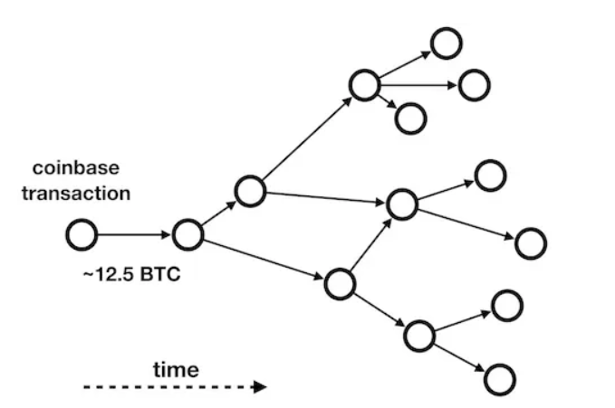
Figure 3. Example of a DAG initiated by a coinbase transaction. The reward for mining a new block is currently 12.5 bitcoins (August 2019). Nodes represent transactions, time flows from left to right.
Figure 4 gives an example visualization of the connected components in the data set:
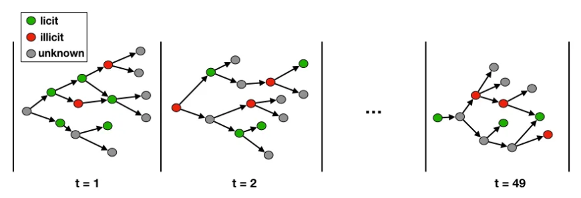
Figure 4. The Elliptic Data Set contains 49 connected components, from the earliest one denoted by the time step t = 1 to the later one with a time step t = 49.
Each connected component is composed of between 1,000 and 8,000 nodes. Most nodes belong to the “unknown” class — as shown in Figure 5.
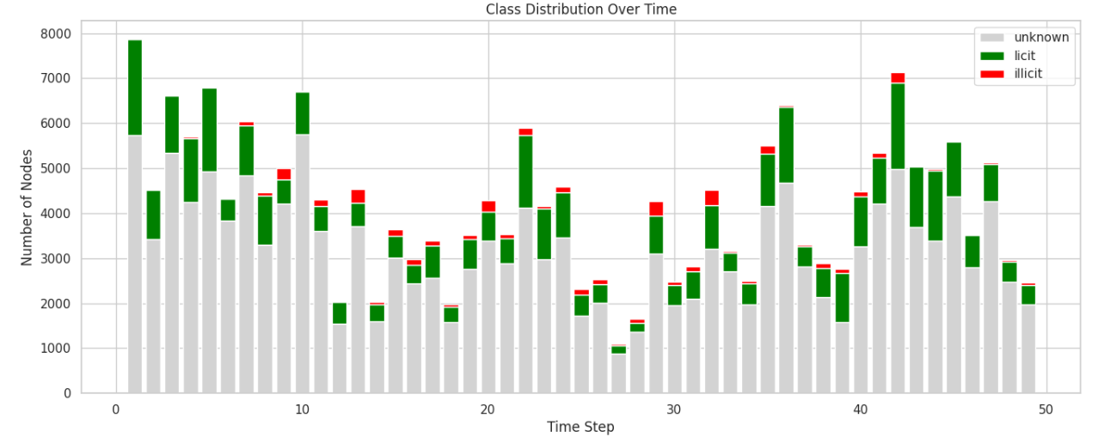
Figure 5. Size and composition of the connected components vs. time step.

CHAPTER 4: METHODOLOGY

4.1. Overall Framework

Different from the research using complex machine learning model, the main goal of this thesis is not to optimize the accuracy of prediction, but to identify and interpret meaningful structural signals in trading networks.

The thesis process was implemented according to the “Chaining” principle of Needham & Hodler (2019), which includes three core stages:
- Label-free Computation: Graph metrics are computed on the full transaction graph, including licit, illicit, and unknown nodes. At this stage, class labels are not used. This ensures that the structural indicators are derived purely from the topology of the Bitcoin transaction network..
- Morphological Diagnosis: The computed graph metrics are interpreted as structural signatures of transaction behavior. For example, degree asymmetry is used to describe accumulation or distribution behavior, betweenness centrality is used to capture intermediary positions, and time-step-based z-scores are used to identify locally unusual transactions.
- Post-hoc Validation: After all graph metrics have been computed, the labelled licit and labelled illicit transactions are compared using descriptive statistics, non-parametric tests, enrichment ratios, and label-coverage diagnostics.

The thesis is structured around three main Problem Statements:

Problem Statement | Analytical focus | Main Research Question
PS1 | Degree and Reachability asymmetry | Do labelled illicit transactions in the Elliptic DAG exhibit systematically different in/out-degree or reachability asymmetry from labelled licit transactions, once the analysis is extended from one-hop (degree) to multi-hop (reachability)?
PS2 | Global centrality | How do betweenness-related global centrality metrics characterise the structural position of labelled illicit transactions in the transaction graph?
PS3 | Temporal anomaly | Do temporal structural variations across timesteps, together with within-timestep structural outlierness, provide meaningful evidence for characterising labelled illicit transactions in the Elliptic Bitcoin transaction graph?

Overall, these three issues explore illicit activities from three dimensions of graph structure: local node configuration, network location, and time context.

4.2. Label Usage and Evaluation Baseline

A central methodological principle of this thesis is the separation between graph-metric computation and label-based evaluation. Graph metrics are calculated without using class labels. Labels are introduced only after the structural metrics have been computed, and they are used solely for post-hoc evaluation.

This distinction is important because the purpose of the thesis is to examine whether structural positions in the Bitcoin transaction graph are associated with labelled illicit activity, not to construct a supervised detection model. Therefore, all graph measures, including degree asymmetry, reachability asymmetry, betweenness centrality, harmonic closeness, bottleneck ratio, PageRank, timestep-level indicators, and within-timestep z-scores, are computed using only graph structure and timestep information.

4.2.1. Label-free metric computation

The thesis distinguishes between label-based evaluation and metric calculation.
During metric computation, the algorithms use:

Information used | Role in metric computation
Transaction nodes | Define the graph vertices
Directed edges | Define Bitcoin transaction-flow relationships
Timestep information | Used for temporal partitioning in PS3
Class labels | Not used during metric computation

The full graph contains all available transactions, including licit, illicit, and unknown nodes. Unknown nodes are retained during graph computation because they are real transactions and influence the topology of the transaction network. Excluding them would distort path structure, centrality scores, degree distributions, and temporal connectivity.

4.2.2. Label groups used in post-hoc evaluation

After graph metrics have been computed, the metric table is merged with the class-label table. The nodes are then divided into three groups:

Label group | Meaning | Use in this thesis
Licit | Transactions labelled as licit | Used for class comparison
Illicit | Transactions labelled as illicit | Used for class comparison
Unknown | Transactions without ground-truth labels | Included in graph computation and descriptive plots, excluded from direct class evaluation

The labelled evaluation set contains only licit and illicit transactions:

$$N_{labeled}=N_{licit}+N_{illicit}$$

In the Elliptic dataset:
$$N_{labeled}=42,019+4,545=46,564$$

4.2.3. Baseline illicit rate

The baseline illicit rate is calculated only within the labelled subset:
$$Baseline Illicit Rate=\frac{4,545}{46,564}=9.76\%$$

This baseline serves as the reference point for Enrichment analysis.

Because approximately 77% of nodes are unknown, the absence of illicit labels in a high-scoring subset cannot automatically be interpreted as evidence that the subset is safe. It may simply reflect insufficient label coverage. For this reason, this thesis applies label-coverage diagnostics before reporting enrichment for percentile-based or top-ranked subsets. The execution plan specifically requires that if a bucket contains fewer than 30 labelled nodes or has label coverage below 5%, enrichment should not be reported as a reliable numerical finding.

4.2.4. Enrichment analysis

The enrichment ratio is then defined as:

$$ER(S)=\frac{p_{illicit}(S)}{{base line p}_{illicit}}$$
The interpretation is as follows:

Enrichment ratio | Interpretation
ER(S) > 1 | The subset contains a higher labelled illicit rate than the baseline
ER(S) = 1 | The subset has the same labelled illicit rate as the baseline
ER(S) < 1 | The subset contains a lower labelled illicit rate than the baseline

4.2.5. Label-coverage diagnostics

Because most nodes are unknown, enrichment analysis can be misleading if a selected subset contains too few labelled nodes. A high-scoring structural region may appear to contain few or no illicit transactions simply because almost all nodes in that region are unlabelled.

This issue is especially important for percentile-based analysis, such as the top 1%, top 5%, or top 10% of nodes by betweenness centrality. If a top-centrality bucket contains thousands of nodes but only a small number of labelled observations, the illicit rate computed from the labelled subset is not reliable.

Therefore, before reporting enrichment for any top-ranked or percentile-based subset, this thesis applies a label-coverage diagnostic. For each evaluated subset, the following quantities are reported:

Quantity | Definition
Total nodes in subset | All nodes selected by the structural rule
Labelled nodes in subset | Licit + illicit nodes in the subset
Label coverage | Labelled nodes divided by total nodes
Actual illicit count | Number of labelled illicit nodes in the subset
Expected illicit count | Baseline illicit rate × labelled nodes
Enrichment ratio | Observed illicit rate divided by baseline illicit rate
Action | Whether the subset is usable or insufficiently labelled

Label coverage is computed as:
$$Label Coverage(S)=\frac{N_{labelled​}(S)}{N_{total​}(S)}$$

A subset is treated as insufficiently labelled if either condition holds:

$$N_{labelled​}(S)<30$$

Or
$$Label Coverage(S)<5\%$$

If a subset fails this label-coverage gate, its enrichment ratio is not interpreted as a reliable numerical finding. Instead, the subset is reported as having insufficient label coverage.

This rule is particularly important in PS2, where high-betweenness regions are often dominated by unknown nodes. In such cases, the absence of labelled illicit transactions cannot be interpreted as evidence that the region is licit or safe. It only means that the available labels are insufficient to estimate the illicit rate reliably.

4.3. Problem Statement 1

PS1 investigates if illicit transactions have a different local input-output structure than licit ones. The key notion is that Bitcoin transactions can be locally classified based on how many previous transactions they consume and how many subsequent outputs they generate.

The research question is: “Do illicit transactions show systematically different in-degree, out-degree, or degree asymmetry than licit transactions?”

For each node v, the following degree-based metrics are computed:

$$d_{in}(v) = number of incoming edges$$
$$d_{out}(v) = number of outcoming edges$$
$$d_{total}(v) = d_{in}(v) + d_{out}(v)$$

The main metric in PS1 is the Degree Asymmetry Index (DAI):
$$DAI(v)=\frac{d_{in}(v) - d_{out}(v)}{d_{total}(v)}$$
As mentioned in section 2.2.2,
- DAI ≈ +1 Accumulation behavior: high incoming flow, low outgoing flow
- DAI ≈ −1 Distribution behavior: low incoming flow, high outgoing flow
- DAI ≈ 0 Balanced flow

The absolute asymmetry is also computed: $\left|DAI(v)\right|$
These metrics are produced for all nodes in the network without labeling.

The PS1 analysis is conducted in five phases:

Step 1: Compute degree metrics without labels
Calculations for all 203,769 nodes include in-degree, out-degree, total degree, DAI, and ∣DAI∣.

Step 2: Generate global descriptive statistics.
The thesis provides mean, median, standard deviation, minimum, maximum, and distributional shapes for degree-based measures. It also computes the ratio of pure sources and pure sinks:
$${Pure source: d}_{out}(v) > 0, d_{in}(v) = 0$$
$${Pure sink: d}_{in}(v) > 0, d_{out}(v) = 0$$
Pure sources represent transactions that only distribute value outward within the graph, while pure sinks represent transactions that only receive value without further outgoing flow. These ratios provide a basic structural summary of directional transaction behaviour in the graph.

Step 3: Combine labels for post-hoc evaluation.
After metrics are computed, the degree table is linked to the label table. The nodes are then divided into licit, illicit, and unknown classes.

Step 4: Conducting statistical tests.
The Mann - Whitney U test compares licit and illicit distributions of in-degree, out-degree, total degree, DAI, and ∣DAI∣. Because Bitcoin graph metrics are extremely skewed and heavy-tailed, a nonparametric test is preferable to a t-test. The effect size is measured using rank-biserial correlation.

Output | Meaning
(U) statistic | Rank-based test statistic
p-value | Statistical significance of the distributional difference
Rank-biserial correlation | Non-parametric effect size
Median licit | Median value among labelled licit nodes
Median illicit | Median value among labelled illicit nodes

Because the labelled sample size is large, p-values may become very small even for weak differences. Therefore, rank-biserial correlation is used to evaluate practical effect size.

Step 5: Enrichment analysis.
The thesis then evaluates whether structurally extreme degree-asymmetry subsets contain a higher labelled illicit rate than the baseline. For a specific subset S, the illicit rate is:

$$p_{illicit}(S)=\frac{The number of illicit nodes in S}{Total number of labeled nodes in S}$$
The enrichment ratio is:
$$ER(S)=\frac{p_{illicit}(S)}{p_{illicit}(all labeled nodes)}$$
where the baseline labeled illicit rate is approximately 9.76%.

Enrichment ratio | Meaning
(ER(S)>1) | The subset is enriched for labelled illicit transactions
(ER(S)=1) | The subset has the same illicit rate as the baseline
(ER(S)<1) | The subset is under-enriched for labelled illicit transactions

4.4. Problem Statement 2
PS2 examines the structural positioning of labelled illicit transactions in the full Bitcoin transaction graph using global centrality metrics.
The purpose of PS2 is diagnostic rather than detection-oriented. PS2 does not assume that high centrality directly indicates illicit activity. Instead, it evaluates how far global centrality can support reliable structural interpretation under severe label scarcity.
The PS2 analysis is conducted in six phases.
Step 1: Compute global centrality metrics without labels
The full directed graph is used for global centrality computation. Class labels are not used during this stage.
The main metric is betweenness centrality. For a node vvv, directed betweenness centrality is defined as:
$$B(u)=\sum_{s ≠ u ≠ t}^{ }{\frac{p(u)}{p}}$$
Where
- $u$ is a node
- $p$ is the total number of shortest paths between nodes$s$ and $t$
- $p(u)$ is the number of shortest paths between nodes$s$ and $t$ that pass through node $u$
Since the complete elliptic graph contains 203,769 nodes and 234,355 directed edges, calculating the exact betweenness centrality across the entire graph is computationally expensive. Betweenness centrality requires considering the shortest paths between many pairs of nodes (s,t). For a graph with more than 200,000 nodes, calculating the exact betweenness across all source-destination pairs is not feasible under normal computational conditions.
Therefore, this study uses approximate betweenness centrality in a source-node sampling approach. Instead of using all the nodes in the graph as a source to calculate the shortest path, the algorithm only samples a subset of: k=10,000
To test the stability of the approximation results, the betweenness centrality was iteratively calculated with three different random seeds: Seed ∈ {42, 7, 123}
Then, the degree of similarity between the runs was assessed using test-retest correlation. If the results between the different seeds still show a high correlation, it indicates that the approximation is stable and not overly dependent on a specific random source sample.
In this analysis, the stability test results show a high correlation between the runs, with $ρ≈0.97$.
This value exceeds the stability threshold used in the study: $ρ=0.95$.
Therefore, the sample of k = 10,000 is accepted as the primary parameter for calculating approximate betweenness centrality. The final betweenness value is reported as the median of three runs with different seeds. This approach reduces the influence of random fluctuations during source sampling and makes the centrality results more stable.
Step 2: Compute supplementary centrality metrics
In addition to betweenness, PS2 computes harmonic closeness and bottleneck ratio.
Harmonic closeness is used because the graph is directed and not fully reachable. It is defined as:
$$C_{H}(v)=\sum_{u≠v}{\frac{1}{d(v,u)}}$$
where d(v,u) is the shortest path distance from v to u, and 1/d(v,u) = 0 when u is inaccessible from v.
A normalized version can be computed as:
$$C_{H_norm}(v)=\frac{C_{H}(v)}{\left|V\right|-1}$$

The bottleneck ratio is computed to adjust betweenness by local connectivity. The rationale is that large hubs may have high betweenness simply because they have high degree, while a true bottleneck may have high betweenness relative to its degree environment.
$$BR(υ) =\frac{B(υ)}{d\left(υ\right) . {\overline{d}}_{N} \left(υ\right)+ ε }$$
where:
- $B(υ)$ denotes the normalized betweenness centrality of node v;
- $d\left(υ\right)$ denotes the total degree of node v
$d\left(υ\right) = d_{in}\left(υ\right) + d_{out}\left(υ\right)$
- ${\overline{d}}_{N} \left(υ\right)$ = the average total degree of all neighbouring nodes of v;
- $ε= {10}^{-12}$ is a small constant added to avoid division by zero.

Step 3: Generate global descriptive statistics
After centrality metrics are computed, PS2 reports descriptive statistics for all nodes, including mean, median, standard deviation, minimum, maximum, non-zero fraction, and selected percentiles. Reporting descriptive statistics helps show whether the metric is broadly distributed or concentrated in a small top-ranked region.
Step 4: Combine labels for post-hoc evaluation
After metric computation, the centrality table is merged with the class-label table. Nodes are divided into licit, illicit, and unknown groups.
The thesis then compares centrality distributions across labelled licit and labelled illicit transactions. Unknown nodes are included in descriptive summaries but excluded from direct class tests.
Step 5: Apply label-coverage diagnostics before enrichment
Because the Elliptic dataset contains a large unknown-label population, PS2 applies a label-coverage gate before reporting any enrichment value in high-centrality buckets.
For each percentile bucket, the thesis reports:
Field | Meaning
Percentile bucket | Top 0.5%, 1%, 2%, 5%, 10%, or 20%
Total nodes | Number of nodes in the bucket
Labelled nodes | Number of licit or illicit nodes in the bucket
% labelled | Labelled nodes divided by total nodes
Actual illicit | Observed number of labelled illicit nodes
Expected illicit | Baseline illicit rate × labelled nodes
Illicit rate | Actual illicit divided by labelled nodes
Enrichment ratio | Illicit rate divided by baseline illicit rate
Action | Whether the bucket is usable or insufficiently labelled
A bucket is treated as unreliable if:
$$N_{labelled}<30$$
Or
$$\%labelled<5\%$$
If either condition is met, the bucket is reported as having insufficient label coverage. In that case, the thesis does not interpret the illicit rate or enrichment ratio as a reliable result. A high-centrality bucket with very few labelled nodes cannot be used to conclude that illicit transactions are absent. It only shows that the region is not sufficiently labelled for reliable evaluation.
Step 6: Conduct statistical tests and structural interpretation
For centrality metrics that have sufficient labelled observations, the Mann–Whitney U test is used to compare labelled licit and labelled illicit distributions. Rank-biserial correlation is reported as the effect size.
The thesis also conducts top-node inspection and cross-metric interpretation. This includes examining the highest-betweenness nodes and comparing betweenness with other structural indicators such as degree and asymmetry.
The purpose is not to produce a direct detection rule. Instead, PS2 evaluates whether global centrality provides an interpretable structural account of labelled illicit transactions under label-coverage constraints.

4.5. Problem Statement 3
PS3 examines temporal structural behaviour in the Elliptic transaction graph. It evaluates both cross-timestep variation and within-timestep node-level outlierness.
The purpose of PS3 is to determine whether labelled illicit transactions are associated with temporal structural patterns. Unlike PS1 and PS2, PS3 does not treat the full graph as a single static network. Instead, it uses the 49 timesteps to analyse how structure changes across time and how individual transactions behave relative to their temporal peers.
The PS3 analysis is conducted in seven phases.
Step 1: Partition the graph into timestep subgraphs
The full graph is divided into 49 timestep-specific subgraphs:
$$G_{1}, G_{2}, G_{3}, ..., G_{49}$$
where each $G_{t}=(V_{t}, E_{t})$ contains the transactions and edges belonging to timestep t.
This step establishes the temporal structure of the dataset and shows whether each timestep differs in size, density, and connectivity.
Step 2: Compute node-level metrics within each timestep
Within each timestep subgraph, graph metrics are computed without using labels. These include:
Metric | Meaning
In-degree | Number of incoming edges within the timestep
Out-degree | Number of outgoing edges within the timestep
Total degree | Sum of in-degree and out-degree
Raw asymmetry | Directional imbalance between incoming and outgoing links
Betweenness | Local intermediary role within the timestep
PageRank | Local transitive influence
Clustering coefficient | Local neighbourhood closure
Component size | Size of the weakly connected component
Betweenness is computed separately within each timestep. To reduce approximation instability, the computation is repeated using multiple random seeds, and the median value is used as the final betweenness estimate.
This allows PS3 to evaluate whether a transaction is structurally important relative to its own timestep, rather than relative to the entire graph.
Step 3: Compute within-timestep z-scores
Because different timesteps have different graph sizes and metric distributions, raw metric values are not directly comparable across time. Therefore, each node metric is standardized within its own timestep.
For a metric x, the within-timestep z-score is:
$$z_{i,t}= \frac{x_{i,t} - μ_{t}}{σ_{t}}$$
where:
- $x_{i,t}$: metric value of node i in timestep t
- $μ_{t}$: mean of the metric within timestep t
- $σ_{t}$: standard deviation of the metric within timestep t
The main z-score metrics are:
Z-score metric | Raw metric | Purpose
$$z_{betweenness​}$$ | Betweenness | Detect unusually intermediary nodes
$$z_{degree​}$$ | Total degree | Detect unusually connected nodes
$$z_{pagerank​}$$ | PageRank | Detect unusually influential nodes
$$z_{asymmetry​​}$$ | Raw asymmetry | Detect unusual accumulator or distributor behaviour
A node is defined as an outlier for a metric if: $z_{i,t} > 2$
Step 4: Build timestep-level aggregate indicators
To analyse cross-timestep structural variation, PS3 computes graph-level aggregate indicators for each timestep. These include:
Timestep-level metric | Meaning
Mean betweenness | Average intermediary level in the timestep
Mean total degree | Average local connectivity
Mean asymmetry | Average direction of flow imbalance
Mean PageRank | Average transitive influence
Fraction of extreme-asymmetry nodes | Share of nodes with strong flow imbalance
Outlier-node fraction | Share of nodes flagged as within-timestep outliers
Degree skewness | Asymmetry of the degree distribution
Degree kurtosis | Tail-heaviness of the degree distribution
Density | Graph density of the timestep
Weakly connected components | Component structure of the timestep
These variables form a 49-row timestep-level dataset. Each row represents one temporal snapshot.
The initial timestep anomaly score is defined as:
$$A_{t}=\max_{j} \left|z_{t,j}\right|$$
where $z_{t,j}$​ is the standardized value of timestep-level metric j at timestep t.
A timestep is initially flagged as anomalous if: $A_{t} > 2$
However, because $A_{t}$ is computed as the maximum over several metrics, this rule is vulnerable to a multiple-testing effect. The probability of observing at least one apparently extreme z-score increases as more metrics are tested. Therefore, this thesis also applies a Šidák-corrected threshold.
If m aggregate metrics are tested and the desired two-sided significance level is α = 0.05, the Šidák-corrected per-metric threshold is obtained by:
$$α_{Sidak}=1 - {(1-α)}^{1/m}$$
The corresponding z-score threshold is:
$$z_{Sidak}=Φ^{-1}(1-\frac{α_{Sidak}}{2})$$
$$A_{t} >z_{Sidak}$$
where $Φ^{-1}$ is the inverse cumulative distribution function of the standard normal distribution.
This corrected threshold is used only for the timestep-level aggregate anomaly detector, not for node-level within-timestep outlier detection. The timestep-level detector is then evaluated using null-model calibration. If the number of observed flagged timesteps does not exceed the 95th percentile of the null distribution, no substantive claim is made about confirmed anomalous timesteps.
Step 5: Apply null-model calibration for multiple testing
The timestep anomaly score uses the maximum value across multiple aggregate metrics. This creates a multiple-testing issue, because the probability of observing at least one large z-score increases as the number of tested metrics increases.
To address this, the thesis applies a Gaussian null-model calibration.
The null calibration procedure is:
Step | Procedure
1 | Simulate 10 independent standard-normal z-score series across 49 timesteps.
2 | Apply the same max $z_{i,t} > 2$ anomaly rule.
3 | Record the number of flagged timesteps.
4 | Repeat the procedure 1,000 times.
5 | Compare the observed number of flagged timesteps with the 95th percentile of the null distribution.
The decision rule is:
Condition | Interpretation
Observed flagged count > null 95th percentile | The timestep anomaly detector is considered meaningful
Observed flagged count ≤ null 95th percentile | No substantive timestep-level anomaly claim is made
This step prevents the thesis from treating random max-over-metric artefacts as genuine temporal anomalies.
Step 6: Compute enhanced temporal-context features
The earlier one-hop predecessor/successor design is limited because many transactions have zero or one direct predecessor or successor. In those cases, one-hop statistics such as predecessor-degree standard deviation are often zero by construction.
To address this limitation, PS3 computes enhanced temporal-context features:
Feature | Meaning
count_predecessors_2hop | Number of predecessors within two hops
count_successors_2hop | Number of successors within two hops
mean_predecessor_betweenness_t | Average betweenness of predecessor context
mean_predecessor_asymmetry_t | Average asymmetry of predecessor context
std_predecessor_degree_t | Degree dispersion among predecessors
mean_successor_betweenness_t | Average betweenness of successor context
mean_successor_asymmetry_t | Average asymmetry of successor context
std_successor_degree_t | Degree dispersion among successors
anc_count_t | Number of same-timestep ancestors
desc_count_t | Number of same-timestep descendants
cascade_depth | Longest directed path depth
ts_span_anc | Time span of upstream ancestor context
ts_span_desc | Time span of downstream descendant context
herfindahl_in | Concentration of incoming structural context
herfindahl_out | Concentration of outgoing structural context
flow_velocity | Cascade depth divided by ancestor time span
These features are used to describe temporal neighbourhood and cascade structure. They are treated as supporting descriptive variables rather than the main PS3 result.
Step 7: Conduct post-hoc label evaluation
After all timestep-level, node-level, and context metrics are computed, the metric table is merged with class labels.
The PS3 evaluation is conducted at three levels:
Level | Evaluation
Cross-timestep level | Whether timestep-level structural variation is associated with labelled illicit fraction
Within-timestep node level | Whether metric-specific outliers are enriched for labelled illicit transactions
Context-feature level | Whether enhanced temporal-context features differ descriptively across label groups
The main PS3 enrichment analysis is conducted separately for:
Outlier type
Betweenness outliers
Degree outliers
PageRank outliers
Asymmetry outliers
Any outlier
For the headline result, bootstrap confidence intervals and permutation-null p-values are reported. This ensures that the enrichment result is not merely a product of random label assignment.

4.6. Evaluation Framework
The methodology uses four main forms of evaluation.

4.6.1. Descriptive statistics
For each graph metric, the thesis reports descriptive statistics by class group, including mean, median, standard deviation, minimum, maximum, and selected percentiles. Where relevant, the unknown group is also shown descriptively to assess whether unknown nodes resemble licit nodes, illicit nodes, or a mixture.

4.6.2. Mann - Whitney U test
Because graph metrics such as degree and betweenness are highly skewed and heavy-tailed, this thesis uses the Mann - Whitney U test rather than parametric t-tests. The test compares whether labelled illicit and labelled licit transactions have different metric distributions.
For each metric, the test reports:
Output | Meaning
U statistic | Rank-based test statistic
p-value | Statistical significance of the difference
Rank-biserial correlation | Non-parametric effect size
Median by class | Direction and practical interpretation
The p-value is interpreted cautiously because the labelled sample size is large. Effect size and enrichment are therefore more important for substantive interpretation than statistical significance alone.

4.6.3. Enrichment ratio
Enrichment analysis evaluates whether a selected subset contains a higher proportion of labelled illicit transactions than the labelled baseline.
For a subset S, the illicit rate is:
$$p_{illicit}(S)=\frac{The number of illicit nodes in S}{Total number of labeled nodes in S}$$
The enrichment ratio is:
$$ER(S)=\frac{p_{illicit}(S)}{p_{illicit}(all labeled nodes)}$$
where $p_{illicit}$​ is the baseline illicit rate among all labelled transactions.
Interpretation:
Enrichment ratio | Interpretation
ER = 1 | Same illicit rate as baseline
ER > 1 | Subset is enriched for labelled illicit transactions
ER < 1 | Subset is under-enriched for labelled illicit transactions

4.6.4. Bootstrap confidence intervals and permutation null
For the main enrichment findings, the thesis reports bootstrap confidence intervals and permutation-null p-values. Bootstrap resampling estimates uncertainty around the enrichment ratio, while permutation testing evaluates whether the observed enrichment could arise from random label assignment.
The procedure is:
Step | Procedure
1 | Resample the labelled subset with replacement.
2 | Recalculate the enrichment ratio for each bootstrap sample.
3 | Use the 2.5th and 97.5th percentiles as the 95% confidence interval.
4 | Shuffle labels repeatedly to construct a permutation null distribution.
5 | Compare the observed enrichment ratio against the null distribution.
This evaluation is especially important for PS3, where the headline result is based on enrichment among within-timestep betweenness outliers.

CHAPTER 5: EXPLORATORY DATA ANALYSIS

5.1. Global Graph Properties
The Elliptic Data Set on Kaggle is real transaction data, collected directly from the Bitcoin blockchain network.
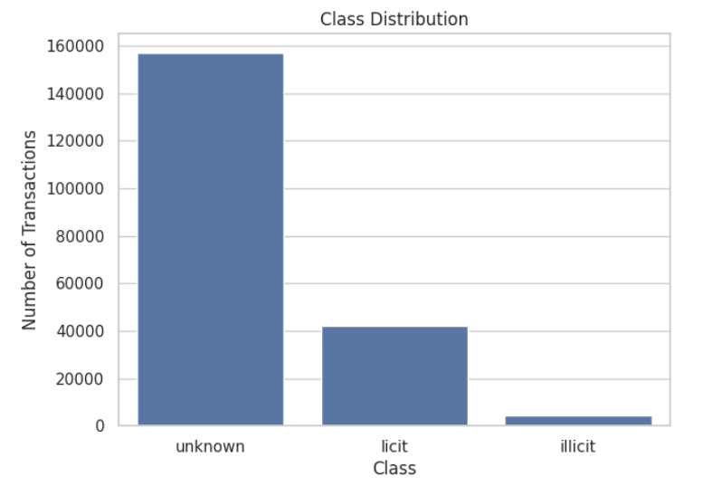
Figure.

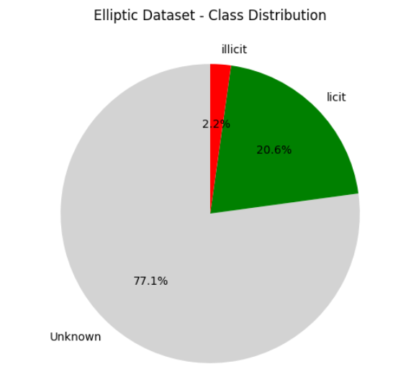
Figure.

The class distribution reveals a class imbalance. Specifically, the unknown class accounts for the largest proportion (~77%), followed by licit (~20.6%), while illicit accounts for only about ~2.2%.

5.2. Class Distribution Over Time
Analysis by time step shows that the number of nodes and edges fluctuates significantly over time, not maintaining a stable level. Specifically, both of these volumes tend to increase and decrease simultaneously, reflecting changes in the size and activity intensity of the trading network over periods.

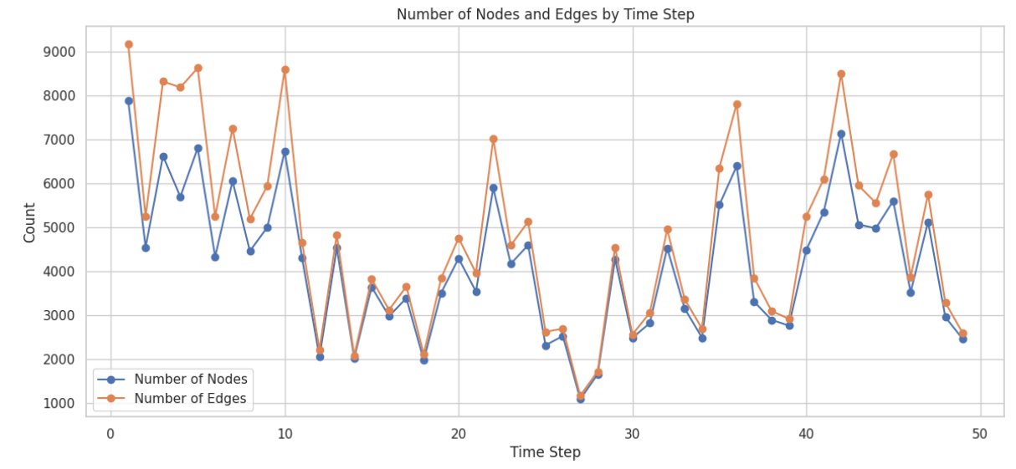
Figure .

The Elliptic dataset is organized into 49 time steps, each representing approximately two weeks of actual transactions on the Bitcoin blockchain. This is a key feature, transforming the dataset into a dynamic graph rather than a typical static one.
Figure 5.3. shows the number of nodes (transactions) and edges (Bitcoin flow) across each time step.
- It can be observed that the number of nodes fluctuates between 1,000 and 9,000 across each time step, with a decreasing trend towards the end of the time series.
- The number of edges fluctuates similarly and correlates closely with the number of nodes, reflecting a relatively stable connection density over time.
- The two highest activity peaks appear at time steps 1-5 and 41-43, possibly corresponding to periods of significant Bitcoin market volatility.

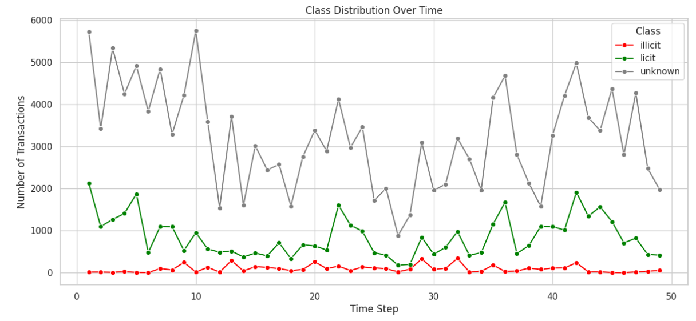
Figure .
Figure 4 shows the change in the number of transactions by class over 49 time steps. Analysis reveals several key characteristics:
- Illicit transactions remain low and relatively stable (typically below 200 transactions/step).
- Licit transactions fluctuate between 0 and 2,000 transactions/step and tend to decrease towards the end of the dataset.
- Unknown transactions account for the largest number at every time step, with a wide range of fluctuation from 1,500 to 5,800 transactions/step.
The changing label distribution over time indicates that the dataset is non-stationary, requiring the classification model to be able to adapt to changes in data distribution over time.

CHAPTER 6: RESULTS

6.1. PS1 - Degree and Reachability Asymmetry

6.1.1. Global Structural Statistics

Table 6.1 shows descriptive data for all degree metric on the entire trading network graph. The degree distribution is strongly right-skewed: the median in-degree and out-degree are both 1, but the maximum values are 284 and 472, respectively, indicating the presence of high-degree hub nodes.

Metric | Count | Mean | Median | Std | Max
In-degree | 203,769 | 1.150 | 1.000 | 3.911 | 284
Out-degree | 203,769 | 1.150 | 1.000 | 1.895 | 472
Total degree | 203,769 | 2.300 | 2.000 | 4.328 | 473
Asymmetry DAI | 203,769 | -0.1086 | 0.000 | 0.687 | 1.000
|Asymmetry| = |DAI| | 203,769 | 0.522 | 0.333 | 0.460 | 1.000
Table 6.1 — Global degree metric statistics
Firstly, a median asymmetry value of 0 indicates that the majority of transactions have a balanced structure between inflows and outflows. This reflects a common characteristic of the Bitcoin transaction network, where many transactions act as intermediaries in the transfer of value.

Secondly, the slightly negative mean (-0.1086) suggests that the entire network tends toward distributed transactions (out-degree > than in-degree), representing a systemic propensity for transactions to give payments more than they receive. However, the relatively large standard deviation (0.687) and wide range from -1 to 1 indicate the existence of nodes with significantly unbalanced structures, which are potential candidates for anomaly analysis.

Additionally, the results indicate that the fraction of pure source nodes (out-degree > 0, in-degree = 0) is 27.15%, while the fraction of pure sink nodes (in-degree > 0, out-degree = 0) is 18.37%. This relatively high proportion of pure sources suggests that a significant share of transactions act as entry points of value flow within the network. The observed proportion of pure source and pure sink nodes may be influenced by the snapshot-based design of the Elliptic dataset, which excludes transactions outside of the observed time periods, resulting in artificial truncation of incoming or outgoing edges.

Metric | Count | Mean | Median | Std | Max
Ancestors | 203,769 | 27.687 | 2.000 | 98.564 | 2770
Descendants | 203,769 | 27.687 | 3.000 | 93.441 | 1462
Reach Asymmetry | 203,769 | -0.172 | -0.405 | 1.787 | 7.927
|Reach Asymmetry| | 203,769 | 1.422 | 1.099 | 1.096 | 7.927
Table 6.2 — Global reachability metric statistics
In addition to one-hop degree structure, PS1 also extends the analysis to multi-hop reachability within the Elliptic DAG. The number of ancestors measures how many upstream transactions can reach a node through directed paths, while the number of descendants measures how many downstream transactions are reachable from that node. Reachability asymmetry is therefore a multi-hop generalisation of degree asymmetry. Unlike degree asymmetry, which only captures immediate input – output imbalance, reachability asymmetry captures whether a transaction is positioned closer to the upstream accumulation side or the downstream propagation side of the DAG.

This result shows that reachability in the Elliptic dataset is highly right-skewed. The majority of nodes have very few ancestors/descendants, but some nodes have very large multi-jump positions. The mean number of ancestors and descendants is 27.687, indicating that upstream and downstream reachability are roughly balanced at the aggregate network level, but the median of descendants (3) are slightly higher than the median of ancestors (2), suggesting the node shape is slightly skewed towards downstream propagation.

The slight negative asymmetry (-0.172) also supports this observation, suggesting that the overall graph has a mild tendency toward downstream propagation rather than upstream accumulation. In other words, a typical transaction can reach slightly more downstream nodes than the number of upstream nodes that can reach it. However, this is only a global statistic, not yet labeled, so no conclusion about illegality can be drawn. It only found a graph with balanced and heavy accessibility structure, requiring further analysis of layer labels and PU-adjusted enrichment.

6.1.2. Class-Stratified Descriptive Statistics

In order to evaluate the role of asymmetry in distinguishing trading behavior, statistics are made for each label group.

Class | N | Mean In-deg | Mean Out-deg | Mean Total-deg | Mean DAI | Mean |DAI|
Illicit | 4,545 | 1.269967 | 0.741694 | 2.011661 | 0.056396 | 0.610412
Licit | 42,019 | 1.909398 | 1.185821 | 3.095219 | -0.069129 | 0.662210
Unknown | 157,205 | 0.943685 | 1.152362 | 2.096047 | -0.123936 | 0.481732
Table 6.2 — Mean degree metrics by class label.
Licit transactions have the highest mean total degree (3.095), showing higher network connectedness and engagement, while illicit transactions have the lowest (2.012), indicating a more confined interaction pattern.
A noteworthy result is that the average Degree asymmetry value of illicit transactions is positive (0.056396), consistent with accumulation behavior, while the trend of permitted and unknown transactions is negative (- 0.069129 and - 0.123936), consistent with distribution behavior.
However, the median value = 0 across all groups suggests that this difference is not centered but appears primarily at the tails of the distribution.

Class | N | Med In-deg | Med Out-deg | Med Total-deg | Med DAI | Med |DAI|
Illicit | 4,545 | 1.0 | 1.0 | 1.0 | 0.0 | 1.0
Licit | 42,019 | 1.0 | 1.0 | 2.0 | 0.0 | 1.0
Unknown | 157,205 | 1.0 | 1.0 | 2.0 | 0.0 | 0.333
Table 6.3 — Median degree metrics by class label.
Table 6.3 shows the median degree metrics stratified by class label. Illicit nodes have a lower median total degree (1.0) than licit nodes (2.0), indicating that illicit transactions are structurally simpler. Both illicit and licit nodes have a median asymmetry of 0.0 (balanced), but the mean |DAI| varies: 0.610 for illicit and 0.662 for licit. Unknown nodes have a lower median |DAI| (0.333), indicating that they are structurally more balanced, which is consistent with unknown nodes containing large service providers with high bidirectional throughput.
Class | N | Med Ancestors | Med Descendants | Med Reach Asymmetry | Med |Reach Asymmetry|
Illicit | 4,545 | 1 | 1 | 0 | 0.9163
Licit | 42,019 | 2 | 2 | -0.2877 | 1.3863
Unknown | 157,205 | 3 | 4 | -0.4055 | 1.0986
Table 6.4 — Class-stratified reachability statistics.
Table 6.4 presents the class-stratified reachability statistics. Labelled illicit transactions have a median of 1 ancestor and 1 descendant, compared with 2 ancestors and 2 descendants for labelled licit transactions. The median signed reachability asymmetry of illicit nodes is 0.000, which is higher than the licit median of −0.288, suggesting a slightly more upstream-oriented or accumulator-like position in directional terms. However, the median absolute reachability asymmetry is lower for illicit nodes (0.916) than for licit nodes (1.386). This indicates that labelled illicit transactions are not concentrated in the most extreme multi-hop reachability positions of the DAG. In short, illicit nodes show a mild directional shift toward upstream accumulation, but their overall multi-hop imbalance is less extreme than that of licit nodes.

6.1.3. Distributional Comparison and KS Statistics

Metric | Comparison | KS_statistic | p-value
DAI | licit vs illicit | 0.118421 | 1.443029e-50
|DAI| | licit vs unknown | 0.144991 | 0.000000e+00
reach_asymmetry | licit vs illicit | 0.158415 | 2.306483e-90
|reach_asymmetry| | licit vs unknown | 0.068147 | 2.488654e-134
Table.
The Kolmogorov–Smirnov test confirms statistically significant distributional separation between labelled licit and labelled illicit nodes for both asymmetry metrics.
For degree asymmetry (DAI), the KS statistic between licit and illicit is 0.118 (p < 10⁻⁵⁰). For reachability asymmetry (RA), the KS statistic increases to 0.158 (p < 10⁻⁸⁹). This suggests that the multi-hop reachability measure provides a slightly stronger distributional separation than the one-hop degree asymmetry measure. However, both statistics remain moderate in magnitude, indicating substantial overlap between the two labelled classes.
The licit–unknown KS statistic for reachability asymmetry is 0.068, which is considerably smaller than the licit–illicit statistic of 0.158. This suggests that, under multi-hop reachability asymmetry, the unknown group is structurally closer to the labelled licit group than to the labelled illicit group. However, unknown nodes are not treated as confirmed licit observations. This finding provides only partial support for the PU-style evaluation used in Section 6.1.6, where unknown nodes are handled cautiously rather than assumed to be randomly distributed across licit and illicit classes.

6.1.4. Statistical Significance by Mann-Whitney U Test and Effect Sizes
Mann–Whitney U tests were conducted for all PS1 metrics. Table 6.4 reports U statistics, p-values, rank-biserial correlations (RBC), and Cliff's delta. The two measures are mathematically equivalent in this context and are reported together for completeness.
Metric | Med Illicit | Med Licit | U statistic | p-value | RBC/  Cliff’s Delta
In-degree | 1.0 | 1.0 | 90,293,567 | 5.55e-11 | -0.054
Out-degree | 1.0 | 1.0 | 77,335,837 | 1.44e-118 | -0.190
Total degree | 1.0 | 2.0 | 71,696,129 | 6.84e-188 | -0.249
Asymmetry (DAI) | 0.0 | 0.0 | 104,354,533 | 1.63e-26 | 0.093
|Asymmetry| (|DAI|) | 1.0 | 1.0 | 91,336,958 | 5.80e-8 | -0.043
Ancestors | 1.0 | 2.0 | 91,971,725 | 3.032e-5 | -0.037
Descendants | 1.0 | 2.0 | 75,044,875 | 7.82e-128 | -0.214
Reach Asymmetry | 0 | -0.28768 | 104,450,170.5 | 2.012e-25 | 0.094
| Reach Asymmetry | | 0.916291 | 1.386294 | 71,001,694.5 | 4.29e-179 | -0.256
Table 6.4 — Mann-Whitney U test results.
Effect sizes are presented as rank-biserial correlation (RBC), with positive RBC indicating that illicit nodes rank higher on the asymmetry metric than licit nodes.

The 10 metrics are statistically significant (p < 10⁻⁷). However, given the large sample sizes (n_illicit = 4,545; n_licit = 42,019), statistical significance alone does not imply practical importance, and effect sizes are examined directly.

The metric DAI yields a positive effect (Cliff's δ ≈ +0.093), confirming that illicit nodes rank higher on metric degree asymmetry than licit nodes, which means that they are more accumulator-like. Metric reachability asymmetry produces a nearly identical positive effect (Cliff's δ ≈ +0.094), indicating that the accumulator orientation persists when the analysis is extended from one-hop degree to multi-hop DAG reachability.

The effect sizes are small with the |RBC| < 0.25.
- Out-degree (RBC = -0.190): Illicit nodes have a lower outflow level, less likely to distribute to many recipients.
- Total degree (RBC = -0.249): Illicit nodes consistently have a lower total connection level, indicating a simpler structure.

By contrast, absolute reachability asymmetry yields a negative effect (Cliff's δ ≈ −0.256), meaning that labelled licit nodes are more likely than illicit nodes to occupy the most extreme multi-hop reachability positions.

Hypothesis check — degree vs reachability: The effect-size comparison confirms that reachability asymmetry (KS = 0.158) provides modestly greater distributional separation than degree asymmetry (KS = 0.118). The hypothesis that multi-hop reachability captures additional discriminatory information beyond one-hop degree is therefore supported, though the difference in effect size is small.

6.1.5. Threshold-Sensitivity Analysis for Degree Asymmetry
To assess whether the enrichment signal is robust to threshold selection and to defend against the appearance of cherry-picking, a continuous scan was conducted across asymmetry thresholds from −1.0 to +1.0 in steps of 0.05. For each threshold, the illicit rate and enrichment ratio were computed for the corresponding accumulator (DAI ≥ t) and distributor (DAI ≤ −t) subsets.

Rule | N total | N labelled | Label coverage | Actual illicit | Illicit rate | Enrichment
Asymmetry <= -0.99 | 55,324 | 15,158 | 0.273986 | 1,205 | 0.079496 | 0.814445
Asymmetry <= -0.95 | 55,333 | 15,162 | 0.274014 | 1,205 | 0.079475 | 0.814230
Asymmetry <= -0.90 | 55,377 | 15,167 | 0.273886 | 1,205 | 0.079449 | 0.813961
Asymmetry <= -0.80 | 55,641 | 15,260 | 0.274258 | 1,205 | 0.078965 | 0.809001
Asymmetry <= -0.70 | 56,050 | 15,369 | 0.274202 | 1,205 | 0.078405 | 0.803263
Asymmetry <= -0.60 | 56,965 | 15,567 | 0.273273 | 1,205 | 0.077407 | 0.793046
Asymmetry <= -0.50 | 58,256 | 15,822 | 0.271594 | 1,205 | 0.076160 | 0.780265
Asymmetry >= 0.50 | 41,147 | 13,819 | 0.335845 | 1,517 | 0.109776 | 1.124671
Asymmetry >= 0.60 | 39,895 | 13,351 | 0.334653 | 1,499 | 0.112276 | 1.150282
Asymmetry >= 0.70 | 38,847 | 12,846 | 0.330682 | 1,483 | 0.115444 | 1.182741
Asymmetry >= 0.80 | 38,258 | 12,435 | 0.325030 | 1,482 | 0.119180 | 1.221009
Asymmetry >= 0.90 | 37,732 | 12,029 | 0.318801 | 1,481 | 0.123119 | 1.261368
Asymmetry >= 0.95 | 37,523 | 11,861 | 0.316099 | 1,481 | 0.124863 | 1.279234
Asymmetry >= 0.99 | 37,424 | 11,785 | 0.314905 | 1,480 | 0.125583 | 1.286615
Table 6.4 — Enrichment analysis by asymmetry threshold. Baseline illicit rate = 9.76%.

The baseline illicit rate among all labeled nodes is 9.76% (4,545 illicit nodes out of 46,564 labeled nodes).
Enrichment rate = (illicit rate in subset) / (base rate) > 1.0 indicates an excessive presence of illicit nodes.
The scan reveals a monotonic enrichment gradient on the accumulator side: enrichment increases as the threshold approaches +1.0, reaching 12.56% illicit rate (enrichment 1.287) at DAI > 0.95. On the distributor side, enrichment is consistently below 1.0 (range 0.79–0.82), confirming that distribution-like transactions are depleted of illicit labels relative to the baseline.

The enrichment signal is statistically consistent but modest in magnitude.
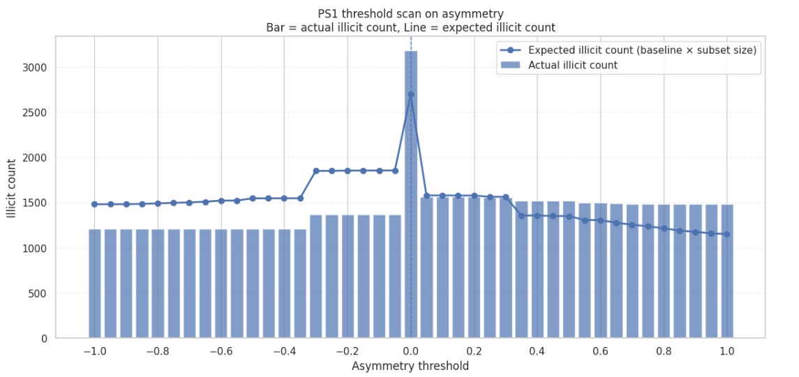
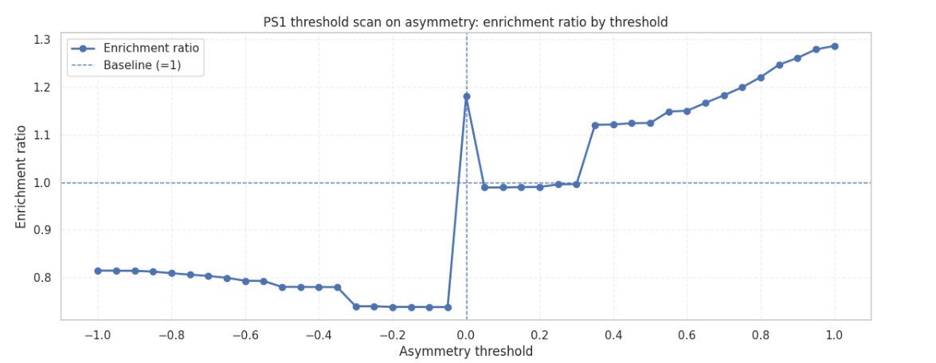
A thorough threshold scan across asymmetry values ranging from -1.0 to +1.0 in 0.05-step increments confirms that enrichment is monotonically increasing on the accumulator side as the threshold approaches +1.0.

On the distributor side, enrichment is typically less than 1.0 (range 0.79x-0.82x). The lack of a strong threshold resulting in substantial enrichment establishes degree asymmetry as a weak-to-moderate signal rather than a discriminative rule.

Analysis of the overall Elliptic graph asymmetry reveals statistically significant signals but modest structural patterns. Illicit transactions exhibit lower overall connectivity (mean global degree = 1 vs. 2 for licit transactions), slight cumulative bias (RBC = +0.093 for DAI), and modest enrichment at high asymmetry thresholds (1.289 for DAI > 0.95). All Mann-Whitney tests achieve p < 10⁻⁷ while all RBC values satisfy |RBC| < 0.25, classifying all effects as minor.

These results motivate, rather than answer, the thesis research question. Asymmetry at the degree level captures one-step structural positioning, while money laundering behaviors may manifest across multiple steps and time windows. Consequently, PS2 extends the analysis to global centrality metrics on the same graph, while PS3 introduces step-by-step temporal structural comparisons.

6.1.6. PU-Adjusted Enrichment with Bootstrap CI and Permutation Null

Metric | Tail | Total nodes | Labelled nodes | % labelled
Asymmetry | Top 0.5% | 37,424 | 11,785 | 31.49
Asymmetry | Bottom 0.5% | 55,322 | 15,156 | 27.40
Asymmetry | Top 1% | 37,424 | 11,785 | 31.49
Asymmetry | Bottom 1% | 55,322 | 15,156 | 27.40
Asymmetry | Top 2% | 37,424 | 11,785 | 31.49
Asymmetry | Bottom 2% | 55,322 | 15,156 | 27.40
Asymmetry | Top 5% | 37,424 | 11,785 | 31.49
Asymmetry | Bottom 5% | 55,322 | 15,156 | 27.40
Asymmetry | Top 10% | 37,424 | 11,785 | 31.49
Asymmetry | Bottom 10% | 55,322 | 15,156 | 27.40
Asymmetry | Top 20% | 41,147 | 13,819 | 33.58
Asymmetry | Bottom 20% | 55,322 | 15,156 | 27.40
Table.
Table 6.5 presents the label-coverage diagnostic for degree asymmetry and reachability asymmetry across percentile buckets from top/bottom 0.5% to top/bottom 20%. Both asymmetry metrics maintain adequate label coverage (≥ 30 labelled nodes and ≥ 5% labelled fraction) at all reported percentile levels, permitting reliable enrichment estimates throughout.
Metric | Tail | N labelled | Illicit rate | Enrichment | 95% bootstrap CI | Permutation p
Degree asymmetry | Positive extreme | 11,785 | 12.56% | 1.287 | [1.227, 1.348] | 0.000999
|Degree asymmetry| | Negative extreme | 15,156 | 7.95% | 0.815 | [0.769, 0.858] | 0.000999
Reachability asymmetry | Top 1% | 982 | 2.44% | 0.250 | [0.156, 0.355] | 0.000999
|Reachability asymmetry| | Bottom 1% | 579 | 0.86% | 0.088 | [0.018, 0.177] | 0.000999
Table.
PU-adjusted enrichment results with 95% bootstrap confidence intervals and permutation-null p-values are reported in Table 6.6. The positive tail of degree asymmetry achieves an illicit rate of 12.56%, corresponding to 1.287× enrichment (95% CI: [1.227, 1.348], permutation p < 0.001). The negative tail shows 7.95% illicit rate, enrichment 0.815× (95% CI: [0.769, 0.858], permutation p < 0.001). Both results are statistically distinguishable from a random label assignment, with confidence intervals lying entirely above or below 1.0 respectively.
For reachability asymmetry, the extreme tails tell a different story. The top 1% of reachability asymmetry contains an illicit rate of only 2.44% (enrichment 0.250×), and the bottom 1% only 0.86% (enrichment 0.088×). Both are strongly depleted of illicit labels. This confirms the finding from Section 6.1.4, extreme multi-hop reachability positions are associated with licit or service-like roles, not with illicit activity. The accumulator signal in reachability asymmetry operates at moderate rather than extreme values.

6.1.7. Summary of PS1 Findings
PS1 establishes three empirical findings about the structural position of labelled illicit transactions in the Elliptic DAG.
First, labelled illicit transactions are modestly more accumulator-like than labelled licit transactions, as measured by both degree asymmetry (Cliff's δ ≈ +0.093) and reachability asymmetry (Cliff's δ ≈ +0.094). The positive tail of degree asymmetry achieves 1.287 enrichment with a confidence interval entirely above 1.0, confirming the signal is not attributable to sampling variation.
Second, extreme multi-hop reachability positions are not a good characteristic of illicit transactions. The extreme tails of reachability asymmetry are strongly depleted of illicit labels (enrichment as low as 0.088). This finding separates the signed accumulator tendency from the extremity of structural position: illicit transactions lean accumulator in direction but are not found at the most extreme network positions.
Third, the effect sizes are uniformly small (all |Cliff's δ| < 0.30). Degree asymmetry provides a statistically significant but weak standalone discrimination signal — not sufficient to support a detection rule in isolation.
These findings motivate rather than resolve the thesis research question. Asymmetry at the degree and reachability levels captures static structural positioning, while money laundering behaviours may be more evident when examined within the temporal context of each timestep. PS3 addresses this by evaluating structural anomalies relative to each node's temporal cohort rather than relative to the full-graph baseline.

6.2 PS2 - Global Centrality

6.2.1. Distribution of Global Betweenness and Harmonic Closeness

Problem Statement 2 examines whether global centrality measures can distinguish between illicit and licit transactions that have been labeled across the entire transaction graph.

Two global centrality metrics were computed for all nodes before labels were introduced: approximate directed betweenness centrality and normalized harmonic closeness. Betweenness was used to capture intermediary or bottleneck positions in the transaction DAG, while harmonic closeness was used to capture reachability in a graph where many node pairs are disconnected.

Metric | Count | Mean | Median | Std. dev. | Max | Non-zero fraction
Betweenness | 203,769 | 8.552e-08 | 0.000000 | 5.974e-07 | 8.943e-06 | 0.2145
Normalized harmonic closeness | 203,769 | 1.566e-05 | 0.000007 | 4.731e-05 | 0.00299 | 0.7285
Table.

Descriptive statistics for the entire network show that betweenness centrality is highly skewed, with the majority of nodes having a value of 0. Specifically, only 21.45% of nodes have a non-zero betweenness (non-zero fraction = 0.214503), while the rest hardly participate in the shortest paths in the network.

Harmonic closeness was less sparse, with 72.85% of nodes having non-zero values, but the absolute scale of normalized harmonic closeness remained very small.

After the centrality metrics were computed label-free, node labels were merged for post-hoc evaluation. The class-wise descriptive statistics are shown below:

Class | N | Mean betweenness | Median betweenness | Mean normalized harmonic closeness | Median normalized harmonic closeness
illicit | 4,545 | 4.934e-09 | 0.000000 | 1.125e-05 | 0.000005
licit | 42,019 | 2.174e-09 | 0.000000 | 2.112e-05 | 0.000007
Unknown | 157,205 | 1.101e-07 | 0.000000 | 1.400e-05 | 0.000009

The comparison reveals two important patterns. First, both labelled illicit and labelled licit nodes had a median betweenness of zero, meaning that the majority of labelled nodes did not occupy global shortest-path intermediary positions. Second, the unknown class had a substantially higher mean betweenness (1.101382e-07) than both labelled illicit (4.934737e-09) and labelled licit nodes (2.174775e-09). This suggests that the globally central region of the graph is dominated by unknown nodes rather than by labelled observations.

For normalized harmonic closeness, illicit nodes also had a lower mean value (1.125711e-05) than licit nodes (2.112480e-05), suggesting that illicit transactions are not globally closer to the rest of the graph under this metric.

6.2.2. Mann–Whitney U tests for global centrality

A Mann–Whitney U test was used to compare labelled illicit and labelled licit nodes for both global betweenness and normalized harmonic closeness. Effect sizes are reported using rank-biserial correlation.

Metric | U statistic | p-value | Rank-biserial correlation | Median illicit | Median licit | Mean illicit | Mean licit
Betweenness | 92,137,005.0 | 1.594e-11 | -0.035095 | 0.000000 | 0.000000 | 4.934e-09 | 2.174e-09
Normalized harmonic closeness | 89,861,726.5 | 2.535e-11 | -0.058923 | 0.000005 | 0.000007 | 1.125e-05 | 2.112e-05

Table 6.X. Mann–Whitney U test results for PS2 metrics

Both tests are statistically significant, but the effect sizes are very small. Betweenness has a rank-biserial correlation of -0.035095, and normalized harmonic closeness has a rank-biserial correlation of -0.058923, indicating only weak distributional differences between labelled illicit and labelled licit nodes.
For betweenness, both groups have a median of 0.000000, showing that most labelled nodes do not occupy global intermediary positions. Although labelled illicit nodes have a slightly higher mean betweenness (4.934e-09) than labelled licit nodes (2.174e-09), the effect size remains too small to suggest meaningful practical separation.
For normalized harmonic closeness, labelled illicit nodes have a lower median (0.000005) and mean (1.125e-05) than labelled licit nodes (0.000007 and 2.112e-05). This suggests that labelled illicit nodes are slightly less centrally reachable in the directed graph, but the difference is weak.
Overall, these results show that global centrality metrics differ statistically between the two labelled classes, but they do not provide a strong standalone structural signal for labelled illicit activity. Their main value in PS2 is diagnostic, especially in relation to label-coverage limitations in high-centrality regions.

6.2.3. Label-coverage diagnostic for global betweenness

Because 77.2% of the graph is unknown, enrichment analysis in top-centrality buckets must be interpreted only after checking label coverage. The label-coverage diagnostic for global betweenness is shown below.

Bucket | Cutoff | Total nodes | Labelled nodes | % labelled | Action
Top 0.5% | 4.138629e-06 | 1,019 | 0 | 0.0000% | Insufficient label coverage
Top 1.0% | 3.019763e-06 | 2,038 | 0 | 0.0000% | Insufficient label coverage
Top 2.0% | 8.188961e-07 | 4,076 | 2 | 0.0491% | Insufficient label coverage
Top 5.0% | 1.403564e-07 | 10,192 | 155 | 1.5208% | Insufficient label coverage
Top 10.0% | 2.208405e-08 | 20,474 | 1,198 | 5.8513% | Usable with caution
Top 20.0% | 4.908057e-10 | 40,807 | 5,128 | 12.5665% | Usable with caution

Table 6.X. Label coverage in top global-betweenness buckets

The diagnostic shows a severe collapse of label coverage in the highest-betweenness region. The top 0.5% and 1% of betweenness nodes contained no labelled nodes at all. The top 2% contained only 2 labelled nodes, and the top 5% contained only 155 labelled nodes, corresponding to just 1.52% label coverage.

Therefore, the most globally central nodes cannot be used to estimate illicit enrichment. A bucket with thousands of transactions but almost no labels cannot support a conclusion that illicit transactions are absent. It only shows that the relevant high-centrality region is largely unlabelled.

This directly changes the interpretation of PS2. A naive reading would suggest that illicit transactions avoid global betweenness hubs. However, the corrected interpretation is that the high-betweenness region has insufficient label coverage to support any reliable illicit-rate estimate.

6.2.4. Coverage-gated enrichment analysis for global betweenness

After applying the label-coverage gate, enrichment values were reported only for buckets with at least 30 labelled nodes and at least 5% label coverage. Under this rule, only the top 10% and top 20% betweenness buckets were usable.

Bucket | Total nodes | Labelled nodes | Label coverage | Actual illicit | Expected illicit | Illicit rate | Baseline illicit rate | Enrichment | Action
Top 0.5% | 1,019 | 0 | 0.0000% | 0 | — | — | 9.7608% | — | Insufficient label coverage
Top 1.0% | 2,038 | 0 | 0.0000% | 0 | — | — | 9.7608% | — | Insufficient label coverage
Top 2.0% | 4,076 | 2 | 0.0491% | 0 | — | — | 9.7608% | — | Insufficient label coverage
Top 5.0% | 10,192 | 155 | 1.5208% | 58 | — | — | 9.7608% | — | Insufficient label coverage
Top 10.0% | 20,474 | 1,198 | 5.8513% | 218 | 116.9339 | 18.1970% | 9.7608% | 1.864× | Usable with caution
Top 20.0% | 40,807 | 5,128 | 12.5665% | 337 | 500.5317 | 6.5718% | 9.7608% | 0.673× | Usable with caution
Table 6.X. Coverage-gated enrichment analysis for global betweenness
For the top 10% betweenness bucket, labelled illicit transactions represented 18.20% of labelled nodes, compared with the labelled baseline of 9.76%. This corresponds to an enrichment ratio of 1.864. Bootstrap evaluation gave a 95% confidence interval of [1.642, 2.095], and the permutation p-value was 0.0000, indicating statistical significance under the label-conditioned evaluation.
However, this result must be interpreted cautiously. The top 10% bucket is broad and does not represent the most globally central backbone. The highest-betweenness buckets—top 0.5%, 1%, 2%, and 5%—failed the label-coverage gate. Therefore, the top 10% enrichment cannot be used to claim that the most globally central nodes are illicit-enriched.
In contrast, the top 20% bucket had an illicit rate of only 6.57%, below the baseline of 9.76%, giving an enrichment ratio of 0.673 with a 95% confidence interval of [0.601, 0.745] and a permutation p-value of 1.0000. This wider bucket therefore does not support illicit enrichment.
Overall, global betweenness produces a limited and inconsistent signal. The strongest centrality region lacks labels, while the broader upper-decile signal is moderate and should be treated as descriptive rather than as a robust detection rule.

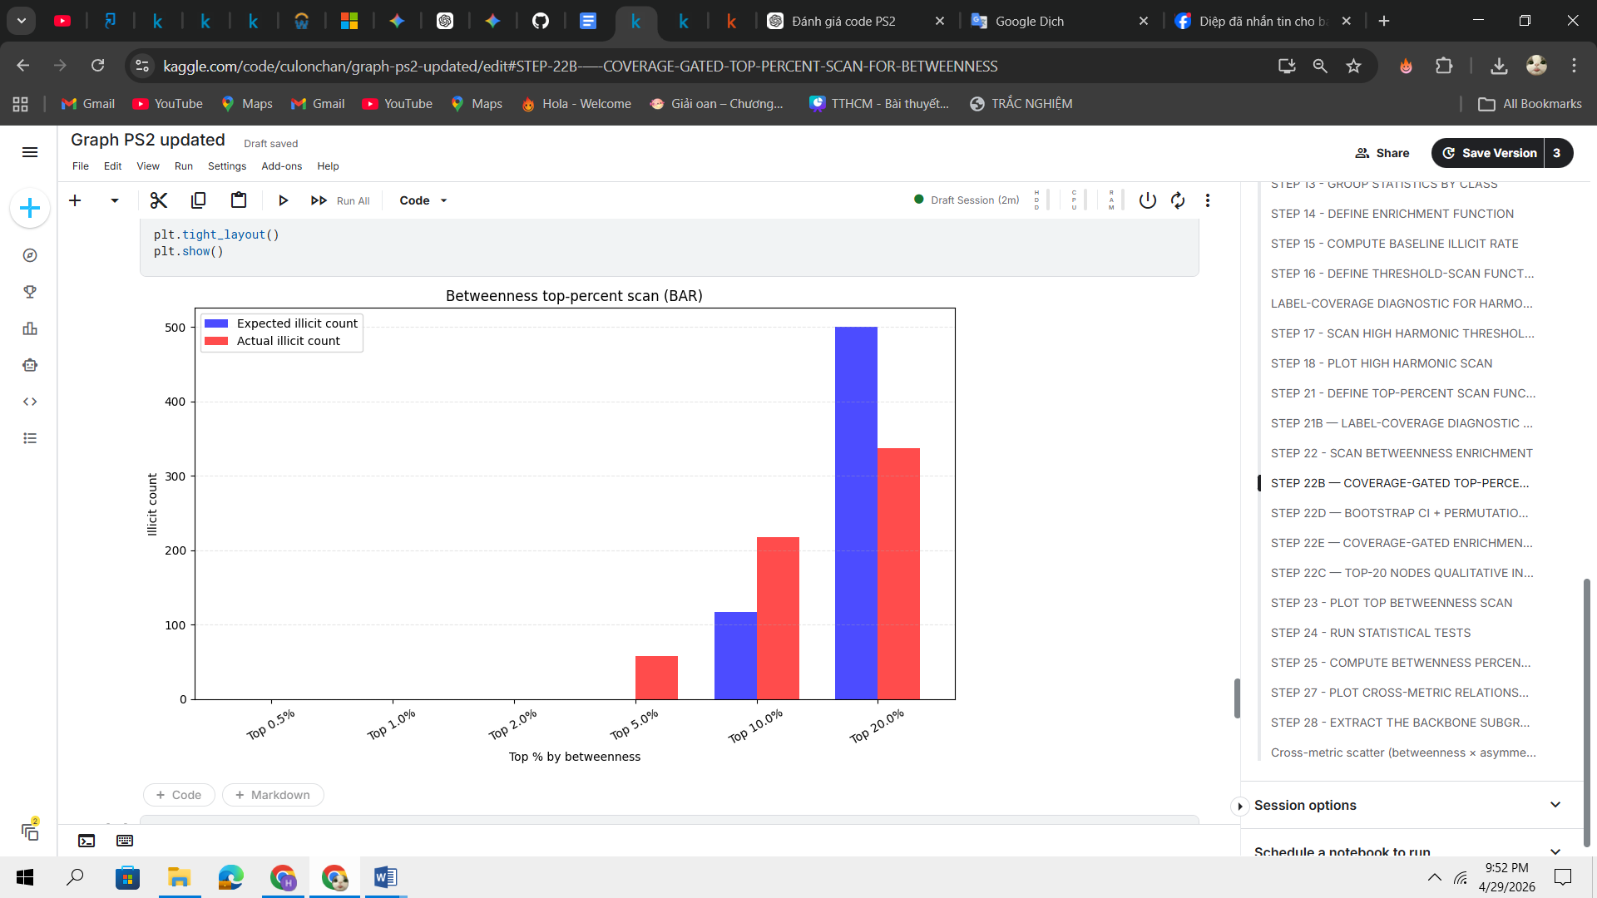
Figure.

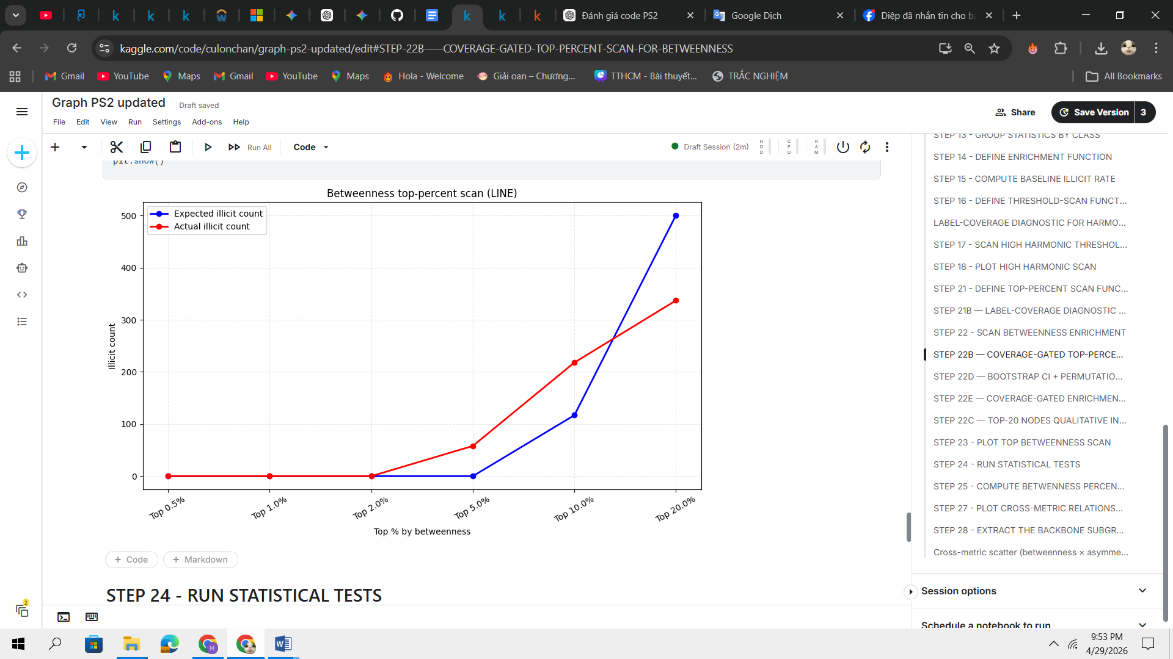
Figure.

6.2.5. Bottleneck ratio analysis

To reduce the dominance of high-degree global hubs, a bottleneck ratio was computed.

The purpose of this metric was to distinguish nodes with high intermediary position relative to their local degree environment. In theory, exchange-like hubs should have high betweenness but also high degree and high-neighbour-degree context, while laundering intermediaries may have high betweenness relative to more moderate degree.

Bucket | Cutoff | Total nodes | Labelled nodes | % labelled | Actual illicit | Expected illicit | Illicit rate | Enrichment | Action
Top 0.5% | 9.667e-07 | 1,019 | 0 | 0.0000% | 0 | — | — | — | Insufficient label coverage
Top 1.0% | 5.967e-07 | 2,038 | 0 | 0.0000% | 0 | — | — | — | Insufficient label coverage
Top 2.0% | 1.411e-07 | 4,076 | 0 | 0.0000% | 0 | — | — | — | Insufficient label coverage
Top 5.0% | 2.420e-08 | 10,189 | 134 | 1.3151% | 93 | — | — | — | Insufficient label coverage
Top 10.0% | 3.680e-09 | 20,548 | 919 | 4.4725% | 219 | — | — | — | Insufficient label coverage
Top 20.0% | 5.074e-11 | 40,754 | 4,911 | 12.0504% | 340 | 479.3509 | 6.9232% | 0.709 | Usable with caution
Table 6.X. Label coverage and enrichment for bottleneck ratio

The bottleneck ratio did not resolve the label-coverage problem. The top 0.5%, 1%, and 2% bottleneck-ratio buckets contained no labelled nodes. The top 5% and 10% buckets contained some labelled nodes but failed the minimum 5% label-coverage threshold. Only the top 20% bucket passed the coverage gate, but it showed under-enrichment, with an illicit rate of 6.92% and an enrichment ratio of 0.709 relative to the labelled baseline.
Thus, bottleneck ratio does not provide evidence of illicit concentration in the globally central region. Instead, it reinforces the main PS2 finding: global centrality-based prioritisation is strongly constrained by missing labels in the highest-ranked regions.

6.2.6. Harmonic closeness analysis

Normalized harmonic closeness was also evaluated because it can handle disconnected directed graphs better than standard closeness centrality. Unlike betweenness, harmonic closeness had adequate label coverage across the top percentile buckets.

Bucket | Total nodes | Labelled nodes | % labelled | Action
Top 0.5% | 1,019 | 521 | 51.13% | OK
Top 1.0% | 2,038 | 888 | 43.57% | OK
Top 2.0% | 4,076 | 1,691 | 41.49% | OK
Top 5.0% | 10,189 | 3,989 | 39.15% | OK
Top 10.0% | 20,383 | 5,487 | 26.92% | OK
Top 20.0% | 40,767 | 8,540 | 20.95% | OK
Top 30.0% | 61,554 | 12,309 | 20.00% | OK
Top 50.0% | 117,552 | 23,370 | 19.88% | OK
Table 6.X. Label coverage for harmonic closeness
However, despite adequate label coverage, high harmonic closeness was not associated with illicit enrichment. Instead, the illicit rate generally decreased as the harmonic threshold became more selective.

Threshold rule | Labelled nodes | Actual illicit | Expected illicit | Illicit rate | Enrichment
Harmonic closeness ≥ 0.000007 | 23,370 | 2,214 | 2,281.0895 | 9.4737% | 0.971
Harmonic closeness ≥ 0.000010 | 15,958 | 1,023 | 1,557.6220 | 6.4106% | 0.657
Harmonic closeness ≥ 0.000014 | 12,309 | 658 | 1,201.4519 | 5.3457% | 0.548
Harmonic closeness ≥ 0.000017 | 10,259 | 550 | 1,001.3563 | 5.3611% | 0.549
Harmonic closeness ≥ 0.000019 | 8,540 | 457 | 833.5689 | 5.3513% | 0.548
Harmonic closeness ≥ 0.000022 | 6,884 | 356 | 671.9307 | 5.1714% | 0.530
Harmonic closeness ≥ 0.000027 | 5,487 | 184 | 535.5729 | 3.3534% | 0.344
Harmonic closeness ≥ 0.000038 | 3,989 | 105 | 389.3567 | 2.6322% | 0.270
Harmonic closeness ≥ 0.000064 | 2,465 | 61 | 240.6027 | 2.4746% | 0.254
Harmonic closeness ≥ 0.000170 | 888 | 30 | 86.6755 | 3.3784% | 0.346
Table 6.X. High harmonic-closeness threshold scan
These results indicate that globally high harmonic closeness is not a useful structural indicator of labelled illicit activity. The top harmonic-closeness regions are sufficiently labelled, but they are dominated by licit rather than illicit transactions. This contrasts with the betweenness result, where the strongest limitation is not necessarily under-enrichment but the collapse of label coverage in the highest-centrality region.

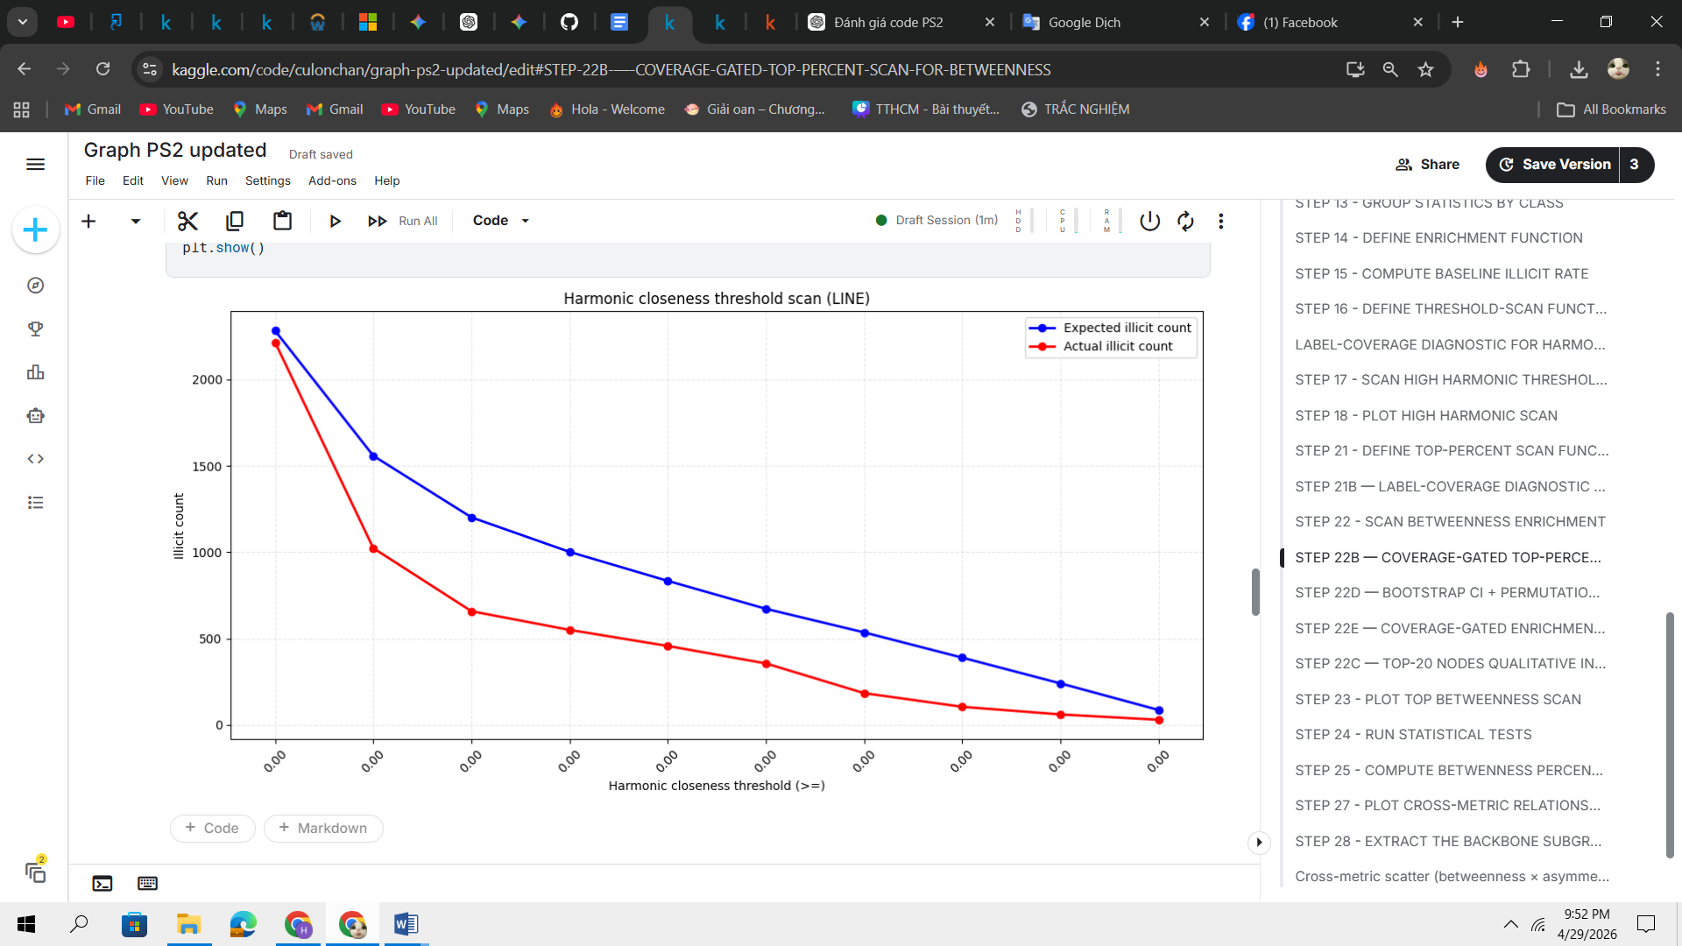

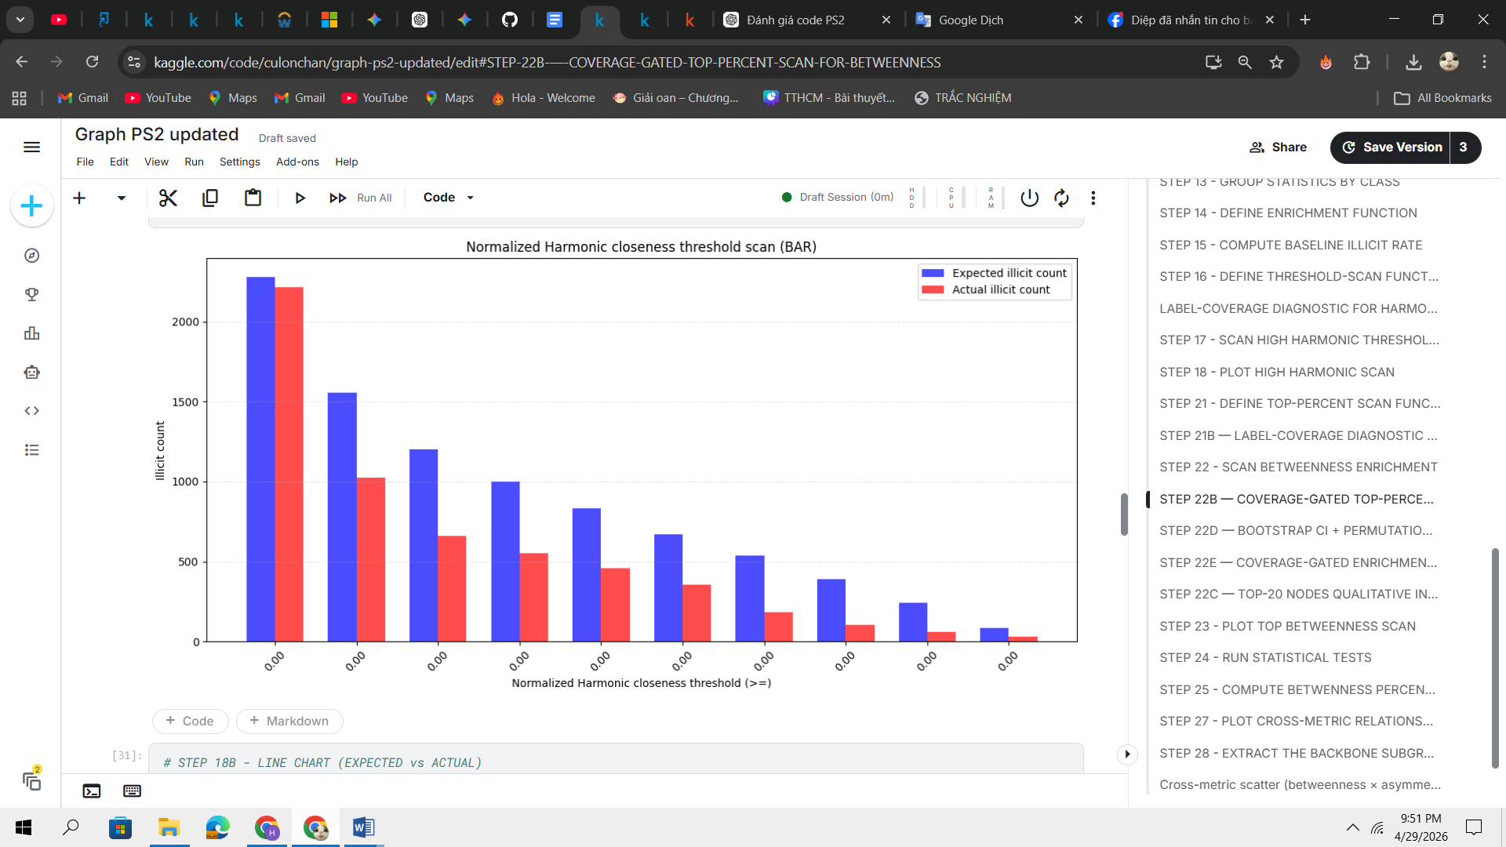

6.2.7. Backbone subgraph and top-node inspection

The top 1% of nodes by global betweenness was extracted as a backbone subgraph. This subgraph contained 2,038 nodes, 2,031 edges, and 7 weakly connected components. However, the top 20 nodes by betweenness were all labelled as unknown. Their mean total degree was only 2.1, and no labelled illicit or licit node appeared in this top-20 list.

This inspection supports the label-coverage finding. The most globally central nodes cannot be interpreted reliably using the available labels because they are overwhelmingly unknown. Therefore, the analysis cannot conclude that these nodes are licit hubs, illicit intermediaries, or exchange-like entities. The only defensible conclusion is that the global-betweenness backbone is label-sparse.

No. | txId | betweenness | In  degree | Out  degree | Total  degree | bottleneck_ratio | class_label
1 | 226999213 | 0.000009 | 1 | 1 | 2 | 2.235764e-06 | unknown
2 | 246058720 | 0.000009 | 1 | 1 | 2 | 2.233065e-06 | unknown
3 | 246059747 | 0.000009 | 1 | 1 | 2 | 1.786452e-06 | unknown
4 | 246058956 | 0.000009 | 1 | 1 | 2 | 2.230489e-06 | unknown
5 | 246059754 | 0.000009 | 1 | 2 | 3 | 4.460732e-07 | unknown
6 | 246058960 | 0.000009 | 1 | 1 | 2 | 2.227912e-06 | unknown
7 | 246059759 | 0.000009 | 1 | 1 | 2 | 1.782035e-06 | unknown
8 | 246058965 | 0.000009 | 1 | 1 | 2 | 1.780269e-06 | unknown
9 | 246060150 | 0.000009 | 1 | 1 | 2 | 2.224845e-06 | unknown
10 | 245440870 | 0.000009 | 1 | 2 | 3 | 8.891037e-07 | unknown
11 | 246060235 | 0.000009 | 1 | 1 | 2 | 2.222146e-06 | unknown
12 | 105937223 | 0.000009 | 1 | 1 | 2 | 1.777852e-06 | unknown
13 | 246060412 | 0.000009 | 1 | 1 | 2 | 2.219447e-06 | unknown
14 | 246059319 | 0.000009 | 1 | 1 | 2 | 2.217238e-06 | unknown
15 | 246060415 | 0.000009 | 1 | 1 | 2 | 2.216748e-06 | unknown
16 | 246059329 | 0.000009 | 1 | 1 | 2 | 2.214662e-06 | unknown
17 | 109906964 | 0.000009 | 1 | 1 | 2 | 2.214048e-06 | unknown
18 | 246059332 | 0.000009 | 1 | 1 | 2 | 1.769668e-06 | unknown
19 | 246060419 | 0.000009 | 1 | 1 | 2 | 2.211349e-06 | unknown
20 | 245440516 | 0.000009 | 1 | 2 | 3 | 8.034578e-07 | unknown

6.2.8. Summary of PS2 findings

The PS2 results show that global centrality is not a reliable standalone signal for diagnose illicit transactions in the Elliptic graph.

First, global betweenness is extremely sparse, with a median of zero and only 21.45% of nodes having non-zero values. Second, the highest-betweenness buckets suffer from severe label-coverage collapse. The top 0.5% and 1% betweenness buckets contain no labelled nodes, while the top 5% bucket has only 1.52% label coverage. Therefore, the most globally central part of the graph cannot be used to estimate illicit enrichment.

Third, the only betweenness bucket that showed statistically significant enrichment was the broader top 10% bucket, where labelled illicit nodes appeared at 18.20%, corresponding to 1.864 enrichment over the baseline. However, this bucket is too broad to support a claim about the most central global hubs. The top 20% bucket was under-enriched, with an enrichment ratio of only 0.673.

Fourth, bottleneck ratio did not rescue the global-centrality approach. Its highest-ranked buckets also failed the label-coverage gate, and the only usable bucket, the top 20%, was under-enriched at 0.709. Finally, harmonic closeness had adequate label coverage, but high harmonic closeness was associated with lower illicit rates rather than enrichment.

This result motivates the transition to PS3. Instead of asking whether a transaction is globally central across the full 49-timestep graph, PS3 asks whether a transaction is structurally unusual relative to other transactions in the same timestep. This reframing is consistent with the idea that laundering behaviour may appear as transient temporal prominence rather than all-time global centrality.

6.3 Results – PS3

PS3 examines whether temporal structural information provides additional evidence for distinguishing labelled illicit transactions from labelled licit transactions. Unlike PS1 and PS2, which compute structural metrics on the full graph, PS3 evaluates each transaction relative to its own temporal context.

The Elliptic transaction graph contains 203,769 nodes and 234,355 directed edges. The graph is a Directed Acyclic Graph (DAG), consistent with the Bitcoin UTXO structure. Since each transaction appears only once, the same node cannot be tracked repeatedly across different time windows. Therefore, PS3 does not measure “node-level change over time”. Instead, it measures whether a transaction is structurally unusual compared with other transactions in the same timestep.

The PS3 analysis consists of three components: timestep-level aggregate anomaly detection, within-timestep node outlier detection, and enhanced temporal-context features.

6.3.1. Per-timestep graph partitioning
he full graph was partitioned into 49 timesteps. For each timestep, a directed subgraph was constructed using transactions belonging to that time window. The per-timestep graph sizes are summarised in Table 6.X.
Table 6.X. Per-timestep graph-size summary
Statistic | Number of nodes | Number of edges | Density | Weakly connected components
Count | 49 | 49 | 49 | 49
Mean | 4,158.55 | 4,782.76 | 0.000318 | 1.0
Std. dev. | 1,592.47 | 2,081.94 | 0.000146 | 0.0
Minimum | 1,089 | 1,168 | 0.000148 | 1
25th percentile | 2,891 | 3,094 | 0.000224 | 1
Median | 4,291 | 4,656 | 0.000261 | 1
75th percentile | 5,121 | 5,950 | 0.000376 | 1
Maximum | 7,880 | 9,164 | 0.000986 | 1
The temporal snapshots vary considerably in size. The smallest timestep contains 1,089 nodes, while the largest contains 7,880 nodes. The number of edges ranges from 1,168 to 9,164. Despite this variation, every timestep contains one weakly connected component, indicating that each temporal snapshot remains structurally connected at the weak-component level.
The graph density is consistently low, with an average of only 0.000318. This confirms that each timestep remains highly sparse.

6.3.2. Per-timestep structural metrics
For each timestep-specific graph, node-level metrics were computed without using class labels. The computed metrics include in-degree, out-degree, total degree, asymmetry, PageRank, clustering coefficient, and approximate betweenness centrality.
Betweenness centrality was computed within each timestep rather than on the full graph. This is important because the objective of PS3 is not to identify globally central transactions, but to identify transactions that are unusually intermediary relative to their own temporal peers.
Approximate betweenness was stabilised using three random seeds: 42, 7, and 123. The final per-node betweenness value was taken as the median across the three runs. This addresses the instability risk of approximate Brandes-style betweenness computation.
Table 6.X. Example per-timestep aggregate structural metrics
Time step | Mean betweenness | Median betweenness | Std. betweenness | Mean total degree | Median total degree | Mean asymmetry | Mean PageRank
1 | 0.000005 | 0.000000 | 0.000028 | 2.325888 | 2.0 | -0.077162 | 0.000127
2 | 0.000041 | 0.000000 | 0.000136 | 2.306778 | 2.0 | -0.082841 | 0.000220
3 | 0.001224 | 0.000002 | 0.002569 | 2.512007 | 2.0 | -0.064495 | 0.000151
4 | 0.000273 | 0.000000 | 0.000711 | 2.873705 | 2.0 | -0.093536 | 0.000176
5 | 0.000007 | 0.000000 | 0.000021 | 2.535058 | 2.0 | -0.114226 | 0.000147
The median betweenness is zero in most early timesteps, showing that most nodes do not act as shortest-path intermediaries even within their temporal snapshot. However, the mean and standard deviation of betweenness vary across timesteps. For example, time step 3 has a mean betweenness of 0.001224, much higher than time steps 1, 2, 4, and 5. This suggests that intermediary structure is not temporally uniform.

6.3.3. Within-timestep z-score standardisation
Because timestep sizes differ substantially, raw graph metrics are not directly comparable across time. Therefore, each node was standardised relative to other nodes in the same timestep.
For each metric x, the within-timestep z-score is defined as:
$$z_{i,t}= \frac{x_{i,t} - μ_{t}}{σ_{t}}$$
where $x_{i,t}$​ is the value of node i in timestep t, and $μ_{t}$ ​ and $σ_{t}$ are the mean and standard deviation of the same metric within that timestep.
Table 6.X. Within-timestep z-score metrics
Z-score metric | Raw metric | Interpretation
z_betweenness_t | Per-timestep betweenness | Whether the node is unusually intermediary within its own timestep
z_degree_t | Total degree | Whether the node has unusually high or low local connectivity
z_asymmetry_t | Raw asymmetry | Whether the node is unusually accumulator-like or distributor-like
z_pagerank_t | PageRank | Whether the node has unusually high transitive influence within the timestep
A node is flagged as a within-timestep outlier if at least one z-score exceeds the threshold ∣z∣>2.

6.3.4. Timestep-level anomaly detection and null calibration
The first PS3 approach attempted to detect anomalous time windows. For each timestep, an aggregate anomaly score was computed by taking the maximum absolute z-score across multiple timestep-level metrics, including mean betweenness, mean total degree, mean asymmetry, mean PageRank, fraction of extreme asymmetry, outlier fraction, degree skewness, degree kurtosis, density, and weak-component count.
Under the original rule max∣z∣ > 2, 9 out of 49 timesteps were initially flagged as anomalous.
Table 6.X. Example timestep-level anomaly scores
Time step | Anomaly score | Initial anomaly flag | Mean betweenness | Mean total degree | Mean asymmetry | Outlier-node fraction | Degree skewness | Degree kurtosis
1 | 2.501871 | 1 | 0.000005 | 2.325888 | -0.077162 | 0.036929 | 37.105762 | 1766.369856
2 | 0.920351 | 0 | 0.000041 | 2.306778 | -0.082841 | 0.086268 | 10.550242 | 186.680447
3 | 3.675613 | 1 | 0.001224 | 2.512007 | -0.064495 | 0.166893 | 6.319671 | 53.593381
4 | 4.001569 | 1 | 0.000273 | 2.873705 | -0.093536 | 0.096434 | 23.568147 | 790.146299
5 | 1.800973 | 0 | 0.000007 | 2.535058 | -0.114226 | 0.083199 | 26.806668 | 1109.805428
However, this initial detector suffers from a multiple-testing problem because each timestep is evaluated using the maximum value across approximately ten metrics. Therefore, a null-model calibration was required before any claim about anomalous time windows could be made. The execution plan specifically requires this calibration before reporting any timestep-level anomaly claim, because the max-over-multiple-metrics rule can generate apparent anomalies by chance.
A Gaussian null model was simulated using 1,000 runs. Each simulation generated 49 timesteps and 10 independent z-score metrics, then applied the same max∣z∣ > 2 rule.
Table 6.X. Null-model calibration for timestep-level anomaly detection
Item | Value
Number of timesteps | 49
Number of metrics tested | 10
Original threshold | max∣z∣ > 2
Observed flagged timesteps | 9
Null mean flagged timesteps | 18.2
Null median flagged timesteps | 18.0
Null 95th percentile | 24.0
Observed percentile in null distribution | 0.1%
Decision | Fail
The observed count of 9 flagged timesteps is below the null mean of 18.2 and far below the null 95th percentile of 24.0. Therefore, the apparent timestep anomalies are not statistically meaningful under this broad max-over-metrics rule.
A Šidák-corrected threshold was then applied to adjust for testing multiple metrics. The corrected z-threshold was:
z = 2.7996
Under this corrected threshold, 5 timesteps were flagged. However, the corrected detector still failed the null calibration.
Table 6.X. Corrected timestep-level anomaly calibration
Calibration method | Observed flagged timesteps | Null mean | Null 95th percentile | Decision
Original max∣z∣ > 2 | 9 | 18.2 | 24.0 | Fail
Šidák-corrected threshold z=2.7996 | 5 | 2.5 | 6.0 | Fail
FDR correction | 5 | 2.5 | 5.0 | Fail / not above null 95th percentile
The FDR-corrected procedure flagged time steps 3, 4, 6, 22, and 27, but the observed count did not exceed the null 95th percentile. Therefore, this thesis does not claim that these timesteps are statistically confirmed anomalous windows.
This is an important negative result. It shows that broad timestep-level anomaly detection based on many aggregate metrics is not robust in this dataset. Consequently, the PS3 analysis shifts from detecting anomalous time windows to identifying node-level outliers within each timestep.

6.3.5. Enhanced temporal-context features
Table 6.X. Enhanced temporal-context features
Feature | Meaning
count_predecessors_2hop | Number of predecessor nodes within two hops
count_successors_2hop | Number of successor nodes within two hops
mean_predecessor_betweenness_t | Mean betweenness of upstream predecessor context
mean_predecessor_asymmetry_t | Mean asymmetry of upstream predecessor context
std_predecessor_degree_t | Degree dispersion among predecessors
mean_successor_betweenness_t | Mean betweenness of downstream successor context
mean_successor_asymmetry_t | Mean asymmetry of downstream successor context
std_successor_degree_t | Degree dispersion among successors
anc_count_t | Number of same-timestep ancestors
desc_count_t | Number of same-timestep descendants
cascade_depth | Longest path depth from a source node
ts_span_anc | Time span of upstream ancestor context
ts_span_desc | Time span of downstream descendant context
herfindahl_in | Degree-based concentration of incoming context
herfindahl_out | Degree-based concentration of outgoing context
flow_velocity | Cascade depth divided by ancestor time span
The final context-feature table contains 203,769 rows and 17 context columns before merging with labels.
Table 6.X. Example enhanced temporal-context feature values
txId | 2-hop predecessors | 2-hop successors | Mean predecessor betweenness | Mean predecessor asymmetry | Std predecessor degree | Ancestor count | Descendant count | Cascade depth | Herfindahl in | Herfindahl out | Flow velocity
230425980 | 2 | 2 | 7.618052e-07 | -0.166667 | 0.500000 | 7 | 2 | 7 | 0.520000 | 0.555556 | 7.0
5530458 | 2 | 1 | 4.444658e-07 | 0.000000 | 0.000000 | 8 | 1 | 8 | 0.500000 | 1.000000 | 8.0
232022460 | 2 | 4 | 0.000000e+00 | 0.000000 | 0.000000 | 3 | 10 | 3 | 0.500000 | 0.929865 | 3.0
232438397 | 289 | 2 | 4.370737e-07 | -0.393613 | 16.967351 | 471 | 5 | 13 | 0.081279 | 0.500000 | 13.0
230460314 | 3 | 20 | 0.000000e+00 | -0.740741 | 1.414214 | 3 | 68 | 3 | 0.343750 | 0.100378 | 3.0

6.3.6. Enrichment analysis of within-timestep outliers
First, all within-timestep outliers were pooled together. This broad definition includes any node with at least one metric satisfying ∣z∣>2.
Table 6.X. Overall within-timestep outlier enrichment
Subset | Labelled nodes | Actual illicit | Expected illicit | Illicit rate | Baseline illicit rate | Enrichment ratio | Lift count
Any within-timestep outlier | 3,007 | 270 | 293.506 | 8.979% | 9.761% | 0.920× | -23.506
The pooled outlier group is not enriched for illicit transactions. It contains 270 labelled illicit nodes, whereas 293.506 would be expected under the baseline. The illicit rate is 8.979%, slightly below the baseline of 9.761%, giving an enrichment ratio of 0.920×.
This result shows that generic structural outlierness is not sufficient. The signal depends on the specific metric used to define the outlier.

6.3.7. Metric-specific outlier enrichment
The analysis was then separated by outlier type: betweenness, PageRank, degree, and asymmetry.
Table 6.X. Enrichment by within-timestep outlier metric
Outlier metric | Labelled nodes | Actual illicit | Expected illicit | Illicit rate | Enrichment ratio | Lift count
Betweenness outlier | 821 | 226 | 80.136 | 27.527% | 2.820× | +145.864
PageRank outlier | 1,510 | 38 | 147.387 | 2.517% | 0.258× | -109.387
Degree outlier | 1,643 | 27 | 160.369 | 1.643% | 0.168× | -133.369
Asymmetry outlier | 269 | 4 | 26.256 | 1.487% | 0.152× | -22.256
The strongest result is found for betweenness outliers. Among 821 labelled betweenness-outlier nodes, 226 are labelled illicit. Under the baseline illicit rate, only 80.136 illicit nodes would be expected. The observed illicit rate is therefore 27.527%, compared with the baseline of 9.761%, producing an enrichment ratio of 2.820×.
By contrast, PageRank, degree, and asymmetry outliers are all under-enriched. Their enrichment ratios are 0.258, 0.168, and 0.152, respectively. This means the PS3 signal is not caused by being generally extreme across any graph metric. It is specifically associated with unusually high within-timestep betweenness.

6.3.8. Label coverage and statistical validation of the headline result
Before reporting enrichment, label coverage was checked. This is necessary because the Elliptic dataset contains a large unknown-label population, and enrichment estimates are only meaningful when the evaluated subset has sufficient labelled observations.
Table 6.X. Label coverage for betweenness outliers
Subset | Total nodes | Labelled nodes | Label coverage | Action
Betweenness outlier nodes | 9,037 | 821 | 9.1% | OK
The betweenness-outlier subset contains 9,037 total nodes, of which 821 are labelled. The label coverage is 9.1%, and the labelled sample size is well above the minimum threshold of 30. Therefore, this subset is acceptable for enrichment analysis.
The enrichment result was then validated using bootstrap confidence intervals and a permutation null.
Table 6.X. Statistical validation of betweenness-outlier enrichment
Item | Value
Total betweenness-outlier nodes | 9,037
Labelled betweenness-outlier nodes | 821
Label coverage | 9.1%
Actual labelled illicit count | 226
Expected illicit count | 80.136
Observed illicit rate | 27.527%
Baseline illicit rate | 9.761%
Enrichment ratio | 2.820
95% bootstrap CI | [2.508, 3.157]
Permutation p-value | 0.0000
Number of shuffles | 1,000
Betweenness seeds | 42, 7, 123
Approximation stability | Median seed-range = 0.000087
The 95% bootstrap confidence interval is [2.508, 3.157], entirely above 1. The permutation p-value is 0.0000, indicating that the observed enrichment is not consistent with random label assignment. This makes within-timestep betweenness outlierness the strongest PS3 result.

6.3.9. Mann–Whitney U tests for PS3 metrics
Mann–Whitney U tests were used to compare labelled illicit and labelled licit nodes across selected PS3 features. Because the labelled sample is large, p-values can become very small even when the practical effect size is limited. Therefore, rank-biserial correlation is reported together with p-values.
Table 6.X. Mann–Whitney U test results for PS3 metrics
Metric | U statistic | p-value | Rank-biserial correlation | Median illicit | Median licit
z_betweenness_t | 83,669,820.0 | 6.603451e-43 | -0.123768 | -0.282321 | -0.266328
z_degree_t | 73,592,236.0 | 1.001949e-142 | -0.229305 | -0.224115 | -0.084961
z_pagerank_t | 90,617,655.5 | 1.532684e-08 | -0.051007 | -0.265699 | -0.267154
mean_predecessor_betweenness_t | 90,180,980.0 | 4.743542e-14 | -0.055580 | 0.000000 | 0.000000
mean_predecessor_asymmetry_t | 89,623,022.5 | 1.532794e-12 | -0.061423 | -0.416667 | -0.250000
The Mann–Whitney tests show statistically significant distributional differences for all reported metrics. However, the effect sizes remain small to modest. For example, z_betweenness_t has rank-biserial correlation -0.123768, while z_degree_t has -0.229305. These values indicate distributional differences, but they do not by themselves provide a clean detection rule.

6.3.10. Timestep anomaly score and illicit fraction
The relationship between timestep-level anomaly scores and illicit fraction was also examined. Under the original anomaly flag, the flagged timesteps did not have a higher illicit fraction than the non-flagged timesteps.
Table 6.X. Illicit fraction in anomalous and non-anomalous timesteps
Group | Number of timesteps | Mean illicit fraction | Median illicit fraction
Initially anomalous timesteps | 9 | 0.069306 | 0.020833
Non-anomalous timesteps | 40 | 0.123415 | 0.109169
The relationship between the timestep-level anomaly score and the labelled illicit fraction was examined only as a descriptive check. The initially anomalous timesteps did not show a higher illicit fraction than the non-anomalous timesteps. Instead, the mean illicit fraction was lower for the initially anomalous group (0.069306) than for the non-anomalous group (0.123415). The median illicit fraction showed the same pattern, with 0.020833 for initially anomalous timesteps compared with 0.109169 for non-anomalous timesteps.
The raw Spearman correlation between timestep anomaly score and illicit fraction was:
p = − 0.352, p = 0.0131
This indicates that higher aggregate anomaly scores were not associated with higher labelled illicit fractions. A partial correlation reported by the code also showed a negative association:
$p_{partial}$ = − 0.414, p = 0.0031
However, this result is treated as descriptive only. Since the timestep-level anomaly detector failed the null-model calibration, this thesis does not claim that aggregate timestep anomaly scores identify illicit-heavy time windows. The main PS3 result remains the node-level within-timestep betweenness - outlier enrichment.

6.3.11. Summary of PS3 findings
The PS3 results show a clear distinction between two types of temporal analysis.
First, aggregate timestep-level anomaly detection is not supported. The initial max-over-metrics detector flagged 9 timesteps, but null calibration showed that this number is below the expected false-positive count under the null. After Šidák and FDR correction, the detector still did not exceed the null 95th percentile. Therefore, no strong claim is made that specific timesteps are statistically anomalous windows.
Second, node-level within-timestep betweenness outlierness is strongly supported. Betweenness outliers contain 226 labelled illicit nodes out of 821 labelled nodes, giving an illicit rate of 27.527% and an enrichment ratio of 2.820× over the baseline. The result is supported by a 95% bootstrap confidence interval of [2.508, 3.157] and a permutation p-value of 0.0000.
This means PS3 does not support the broad statement that “illicit activity occurs during globally anomalous timesteps.” Instead, it supports a more precise interpretation:
Labelled illicit transactions are more likely to appear as local temporal betweenness outliers, transactions that are unusually intermediary compared with other transactions in the same timestep.
This also explains the contrast with PS2. Global betweenness on the full graph is dominated by high-centrality regions with severe label-coverage problems, while per-timestep betweenness asks a different question: whether a node is unusually intermediary relative to its own temporal cohort. Global betweenness measures all-time prominence, whereas per-timestep betweenness measures transient local prominence.

CHAPTER 7: CONCLUSION

7.1. Summary of Findings
This thesis examined whether labelled illicit Bitcoin transactions exhibit interpretable structural and temporal patterns in the Elliptic transaction graph. Rather than developing a predictive machine-learning model, the study adopted a structure-first forensic diagnostic approach: graph metrics were computed without labels, and labels were introduced only for post-hoc evaluation.

The analysis was organised into three problem statements: local structural imbalance, global intermediary position, and temporal structural variation.

PS1 – Local structural imbalance

PS1 examined whether labelled illicit transactions differ from labelled licit transactions in their local inflow–outflow structure. The results show that degree asymmetry and reachability asymmetry provide a useful but moderate structural signal. Labelled illicit transactions tend to be more accumulator-like than labelled licit transactions, but the effect sizes remain limited.

PS2 – Global centrality and label-coverage limitation

PS2 evaluated whether global centrality metrics, including betweenness centrality, harmonic closeness, and bottleneck ratio, characterise the structural position of labelled illicit transactions in the full graph. The main finding is that the highest global-betweenness regions suffer from severe label-coverage collapse. The top 0.5% and top 1% betweenness buckets contain no labelled nodes, while the top 2% and top 5% buckets do not have enough labelled observations for reliable enrichment interpretation.

As a result, the absence of labelled illicit transactions in high-betweenness regions cannot be interpreted as evidence that illicit transactions avoid global hubs. It primarily reflects insufficient label coverage.

PS3 – Temporal structural variation and within-timestep outlierness

PS3 examined temporal structure at two levels: variation across timesteps and outlierness within each timestep. At the timestep level, the aggregate anomaly detector did not survive null-model calibration. Under the original max∣z∣ > 2 rule, 9 timesteps were flagged, but the null model expected about 18.2 flagged timesteps by chance, with a null 95th percentile of 24.0. Even after applying the Šidák-corrected threshold z=2.7996 and FDR correction, the detector did not exceed the null benchmark. Therefore, the thesis does not claim that specific timesteps are statistically confirmed anomalous windows.

At the node level, PS3 produced the strongest empirical finding within the tested graph indicators. Within-timestep betweenness outliers contain 821 labelled nodes, of which 226 are labelled illicit. This gives an illicit rate of 27.527%, compared with the labelled baseline of 9.761%, corresponding to an enrichment ratio of 2.820. The result is supported by a 95% bootstrap confidence interval of [2.508, 3.157] and a permutation p-value of 0.0000.

Overall, the findings show that labelled illicit transactions in the Elliptic graph are better characterised by temporally local structural prominence than by simple global centrality. PS1 provides a local imbalance baseline, PS2 demonstrates the importance of label-coverage diagnostics, and PS3 identifies within-timestep betweenness outlierness as the strongest interpretable signal.

7.2. Contributions

This thesis makes four main contributions.

7.2.1. A structure-first forensic diagnostic framework

The first contribution is methodological. The thesis develops a structure-first framework for analysing illicit Bitcoin transactions without relying primarily on black-box prediction models. Graph metrics are computed without labels, and class labels are used only for post-hoc evaluation. This separation reduces the risk of circular reasoning and allows the structural meaning of each metric to be interpreted more clearly.

This framework is especially suitable for forensic analysis, where explainability is important. Instead of asking only whether a model can classify transactions, the thesis asks where labelled illicit transactions are structurally located in the transaction graph and which graph patterns are defensible under label scarcity.

7.2.2. A label-coverage-aware interpretation of global centrality

The second contribution is the reinterpretation of global betweenness centrality under severe label scarcity. A simple reading of global betweenness could suggest that illicit transactions do not occupy high-centrality regions. However, the label-coverage diagnostic shows that the highest-betweenness buckets are overwhelmingly unknown. Therefore, the lack of labelled illicit nodes in those regions is not evidence of illicit absence.

This is an important contribution because it prevents a common interpretive error: confusing missing labels with negative evidence. The thesis demonstrates that global centrality can be structurally meaningful but evaluatively unreliable when the labelled subset is too sparse.

7.2.3. Evidence for within-timestep betweenness as the strongest interpretable signal

The third contribution is empirical. The thesis identifies within-timestep betweenness outlierness as the strongest structural signal among the tested graph indicators. Unlike global betweenness, which is dominated by label-sparse high-centrality regions, within-timestep betweenness compares each transaction with its temporal peers.

This temporal normalisation changes the interpretation of centrality. It shows that illicit behaviour is better captured by asking whether a transaction is unusually intermediary within its own timestep, rather than whether it is globally central across the entire graph.

7.2.4. Robustness controls against overclaiming

The fourth contribution is the use of robustness checks to prevent overinterpretation. The thesis applies label-coverage gates, bootstrap confidence intervals, permutation-null testing, approximation stability checks, and null-model calibration for timestep-level anomalies.

Several apparent signals become weaker or unsupported after calibration. For example, the timestep-level anomaly detector initially appeared to flag unusual time windows, but null-model calibration showed that the result was not statistically meaningful. This negative finding strengthens the thesis because it shows that the final conclusions are not based on uncalibrated anomaly scores.

7.3. Limitations

This thesis has several limitations.

7.3.1. Unknown-label contamination

The largest limitation is the high proportion of unknown labels in the Elliptic dataset. Out of 203,769 nodes, only 46,564 are labelled as licit or illicit, while 157,205 are unknown. This means that all enrichment analysis is based only on the labelled subset.

Therefore, the thesis does not estimate the true illicit rate in the full Bitcoin transaction graph. It estimates enrichment among labelled transactions only. Unknown nodes may include licit transactions, illicit transactions, or transactions that could not be confidently classified. This creates a positive-unlabelled evaluation problem and limits the strength of any claim about the full population.

For this reason, the thesis consistently uses the phrase “labelled illicit transactions” rather than “all illicit transactions”.

7.3.2. Label coverage in high-centrality regions

A second limitation is that some structurally important regions of the graph have very low label coverage. This is especially evident in PS2. The highest global-betweenness nodes are largely unknown, making it impossible to reliably estimate illicit enrichment in those regions.

This limitation does not invalidate the structural analysis, but it limits the interpretation of global centrality. A high-centrality region can be important in the graph but still unusable for licit-versus-illicit evaluation if too few nodes are labelled.

7.3.3. Approximate centrality computation

A third limitation is the use of approximate betweenness centrality. Exact betweenness is computationally expensive on a graph with more than 200,000 nodes and more than 230,000 directed edges. The thesis therefore uses approximate betweenness with sampled source nodes and stability checks across random seeds.

Although the approximation was tested for stability, it remains an approximation. The results should therefore be interpreted as robust structural estimates rather than exact all-pairs centrality values.

7.3.4. Lack of transaction-value edge weights

The public Elliptic edge list does not provide explicit transaction-value weights for every edge. As a result, the analysis is based primarily on graph structure rather than value-weighted flow. Metrics such as Herfindahl concentration are therefore implemented as structural proxies using degree-based proportions, not as direct measures of Bitcoin value concentration.

This limits the ability of the thesis to distinguish between small-value and high-value flows. A value-weighted graph could provide a richer representation of laundering behaviour.

7.3.5. Transaction-level rather than entity-level analysis

The thesis analyses transactions as nodes, not wallet addresses, users, or real-world entities. This is consistent with the Elliptic dataset design, but it means that the analysis does not directly identify actors. A transaction may be part of a broader entity-controlled strategy, but the dataset does not provide full entity-resolution information.

Therefore, the findings should be interpreted as transaction-level structural patterns rather than actor-level conclusions.

7.3.6. Timestep-level anomaly detection was not supported

The thesis attempted timestep-level anomaly detection using aggregate graph statistics, but this detector did not survive null-model calibration. Therefore, no strong claim is made that specific timesteps are statistically confirmed anomalous windows.

This is a limitation of the tested detector, not of temporal analysis in general. A more focused temporal-risk score may still be useful, especially if based on theoretically selected metrics rather than a broad max-over-multiple-metrics rule.

7.4. Future Work
Several directions can extend this thesis.
7.4.1. PU-adjusted evaluation
Future work should develop a more formal positive-unlabelled evaluation framework. Since the unknown group may contain both licit and illicit transactions, standard labelled-only evaluation may be biased. PU-adjusted metrics could help estimate performance or enrichment under different assumptions about the unknown population.
This would allow future research to distinguish between labelled-sample enrichment and possible full-population enrichment.
7.4.2. Focused timestep-level risk scoring
The timestep-level anomaly detector in this thesis was broad and failed null calibration. Future work should test a more focused timestep-level risk score using a smaller number of theoretically motivated metrics, such as mean betweenness, betweenness-outlier fraction, and degree-tail concentration.
Rather than treating timesteps as simply anomalous or non-anomalous, future research could rank timesteps by a focused temporal-risk score and evaluate whether top-ranked timesteps show higher labelled illicit concentration.
7.4.3. Value-weighted graph analysis
Future work should incorporate transaction-value information where available. Value-weighted betweenness, value-weighted reachability, and value-weighted concentration metrics could better capture financial importance than unweighted graph structure alone.
This would be especially useful for distinguishing large licit hubs from smaller laundering intermediaries that may not have high degree but may move significant value.
7.4.4. Entity-level graph construction
Future research could move from transaction-level graphs to address-level or entity-level graphs. Entity resolution would make it possible to analyse behavioural patterns across multiple transactions controlled by the same actor or service.
Such a graph could better capture laundering strategies that are distributed across many transactions but controlled by a smaller number of entities.
7.4.5. Integration with supervised and graph-learning models
Although this thesis does not focus on predictive optimisation, future work could integrate the interpretable structural features identified here into supervised models or graph neural networks. The purpose should not only be to improve prediction, but also to test whether interpretable graph features improve model transparency.
For example, within-timestep betweenness outlierness, degree asymmetry, reachability asymmetry, and bottleneck ratio could be included as explainable features alongside existing transaction features.
7.4.6. External validation on other blockchain datasets
Finally, future research should test whether the findings generalise beyond the Elliptic dataset. The strongest result of this thesis is that labelled illicit transactions are enriched among within-timestep betweenness outliers. This pattern should be evaluated on other blockchain transaction datasets, different time windows, and different labelling regimes.
External validation would help determine whether temporally local intermediary prominence is a general feature of illicit transaction behaviour or a dataset-specific property of Elliptic.

7.5. Final Remarks
This thesis shows that graph analysis can contribute to Bitcoin illicit-transaction research when its claims are carefully framed. The value of the structure-first approach is not that it replaces supervised machine learning, but that it provides interpretable evidence about transaction positioning, label limitations, and temporal structural behaviour.
The main empirical result is that labelled illicit transactions are substantially enriched among within-timestep betweenness outliers. At the same time, the thesis shows that global centrality and broad timestep-level anomaly scores can be misleading without label-coverage diagnostics and null calibration.
The final contribution is therefore both empirical and methodological: illicit transaction analysis should not only ask which nodes receive high structural scores, but also whether those scores remain interpretable under label scarcity, temporal context, and statistical robustness checks.

REFERENCES
- Adloori, H., Dasanapu, V., & Mergu, A. C. (2024). Graph Network Models To Detect Illicit Transactions In Block Chain (arXiv:2410.07150). arXiv. https://doi.org/10.48550/arXiv.2410.07150
- Akoglu, L., Tong, H., & Koutra, D. (2014). Graph-based Anomaly Detection and Description: A Survey (arXiv:1404.4679). arXiv. https://doi.org/10.48550/arXiv.1404.4679
- Bellei, C., Xu, M., Phillips, R., Robinson, T., Weber, M., Kaler, T., Leiserson, C. E., Arvind, & Chen, J. (2024). The Shape of Money Laundering: Subgraph Representation Learning on the Blockchain with the Elliptic2 Dataset (arXiv:2404.19109). arXiv. https://doi.org/10.48550/arXiv.2404.19109
- Caprolu, M., Pontecorvi, M., Signorini, M., Segarra, C., & Pietro, R. D. (2021). A Novel Framework for the Analysis of Unknown Transactions in Bitcoin: Theory, Model, and Experimental Results (arXiv:2103.09459). arXiv. https://doi.org/10.48550/arXiv.2103.09459
- Drasutis, E. (2025). Proxima. A DAG based cooperative distributed ledger (arXiv:2411.16456). arXiv. https://doi.org/10.48550/arXiv.2411.16456
- Elmougy, Y., & Liu, L. (2023). Demystifying Fraudulent Transactions and Illicit Nodes in the Bitcoin Network for Financial Forensics. Proceedings of the 29th ACM SIGKDD Conference on Knowledge Discovery and Data Mining, 3979–3990. https://doi.org/10.1145/3580305.3599803
- Hu, Y., Seneviratne, S., Thilakarathna, K., Fukuda, K., & Seneviratne, A. (2019). Characterizing and Detecting Money Laundering Activities on the Bitcoin Network (arXiv:1912.12060). arXiv. https://doi.org/10.48550/arXiv.1912.12060
- Jourdan, M., Blandin, S., Wynter, L., & Deshpande, P. (2018). Characterizing Entities in the Bitcoin Blockchain (arXiv:1810.11956). arXiv. https://doi.org/10.48550/arXiv.1810.11956
- Kamuhanda, D., Cui, M., & Tessone, C. J. (2023). Illegal Community Detection in Bitcoin Transaction Networks. Entropy, 25(7), 1069. https://doi.org/10.3390/e25071069
- Kappos, G., Yousaf, H., Stütz, R., Rollet, S., & Haslhofer, B. (n.d.). How to Peel a Million: Validating and Expanding Bitcoin Clusters.
- Kipf, T. N., & Welling, M. (2017). Semi-Supervised Classification with Graph Convolutional Networks (arXiv:1609.02907). arXiv. https://doi.org/10.48550/arXiv.1609.02907
- Koronaios, A., & Koloniari, G. (n.d.). Graph-Based Bitcoin Fraud Detection Using Variational Graph Autoencoders and Supervised Learning.
- Koshy, P., Koshy, D., & McDaniel, P. (2014). An Analysis of Anonymity in Bitcoin Using P2P Network Traffic. In N. Christin & R. Safavi-Naini (Eds.), Financial Cryptography and Data Security (Vol. 8437, pp. 469–485). Springer Berlin Heidelberg. https://doi.org/10.1007/978-3-662-45472-5_30
- Lawal, A. A., Ezeife, E., Akande, J. O., Olapade, A., & Olatunji, A. O. (2025). Data Mining for Financial Fraud Detection: Techniques, Case Studies and Challenges. Asian Journal of Mathematics and Computer Research, 32(2), 36–51. https://doi.org/10.56557/ajomcor/2025/v32i29127
- Lin, Z., Luo, Q., Wu, D., Shen, J., Li, L., Nong, X., & Qin, Z. (2026). Detecting illicit transactions in bitcoin: A wavelet-temporal graph transformer approach for anti-money laundering. Scientific Reports, 16(1), 1548. https://doi.org/10.1038/s41598-025-23901-3
- Meiklejohn, S., Pomarole, M., Jordan, G., Levchenko, K., McCoy, D., Voelker, G. M., & Savage, S. (2013). A fistful of bitcoins: Characterizing payments among men with no names. Proceedings of the 2013 Conference on Internet Measurement Conference, 127–140. https://doi.org/10.1145/2504730.2504747
- Reid, F., & Harrigan, M. (2012). An Analysis of Anonymity in the Bitcoin System (arXiv:1107.4524). arXiv. https://doi.org/10.48550/arXiv.1107.4524
- Tovanich, N., & Cazabet, R. (2022). Pattern Analysis of Money Flow in the Bitcoin Blockchain (arXiv:2207.07315). arXiv. https://doi.org/10.48550/arXiv.2207.07315
- Wang, K., Pang, J., Chen, D., Zhao, Y., Huang, D., Chen, C., & Han, W. (2022). A Large-scale Empirical Analysis of Ransomware Activities in Bitcoin. ACM Transactions on the Web, 16(2), 1–29. https://doi.org/10.1145/3494557
- Weber, M., Domeniconi, G., Chen, J., Weidele, D. K. I., Bellei, C., Robinson, T., & Leiserson, C. E. (2019). Anti-Money Laundering in Bitcoin: Experimenting with Graph Convolutional Networks for Financial Forensics (arXiv:1908.02591). arXiv. https://doi.org/10.48550/arXiv.1908.02591
- Willson, V. L. (1976). Critical Values of the Rank-Biserial Correlation Coefficient. Educational and Psychological Measurement, 36(2), 297–300. https://doi.org/10.1177/001316447603600207
- Xiao, B., & Yin, W. (2025). Balanced-BiEGCN: A Bidirectional EvolveGCN with a Class-Balanced Learning Network for Dynamic Anomaly Detection in Bitcoin. Entropy, 27(10), 1045. https://doi.org/10.3390/e27101045
- Zhao, X., Zhang, L., Zou, T., & Zhang, Y. (2025). Temporal Attention Evolutional Graph Convolutional Network for Multivariate Time Series Forecasting (arXiv:2505.00302). arXiv. https://doi.org/10.48550/arXiv.2505.00302

